

**KronoDesk® Administration Guide**

Version 3.0

Inflectra Corporation

Contents

Contents 1

1. Introduction 1

2. Installing KronoDesk® 2

2.1. System Prerequisites 3

2.2. Installing the Software 6

2.3. Security Considerations 14

3. System Administration 15

3.1. System Settings 16

3.2. Users 27

3.3. Forum Settings 37

3.4. Knowledge Base Settings 40

3.5. Help Desk Settings 42

3.6. Workflows 48

3.7. Event Notifications 53

4. Appendices 58

4.1. Appendix A – Troubleshooting 58

4.2. Appendix B – Using with SSL 62

4.3. Appendix C – Sending Email through IIS 67

4.4. Appendix D – Upgrading 68

Legal Notices 70

# 1. Introduction

KronoDesk® is an integrated customer support system that includes help desk ticketing, customer support forums and an online knowledge base in a single user interface.

KronoDesk® includes a powerful and flexible help desk ticketing system that can be quickly and easily tailored to meet your support needs. With support for custom fields and workflows you can create different support processes for your different products.

KronoDesk® provides a knowledge base and online support forums. making your customers more self-sufficient with routine issues so that your support personnel can focus their time on the critical issues and complex enquiries.

This administration guide outlines how to setup a working installation of KronoDesk®, and how to perform routine administrative tasks.

It assumes a basic understanding of how to setup and administer a Windows Server®, or Windows® workstation, and also assumes that you have access to a valid Administrator level account.

For information on how to use the features of KronoDesk®, please refer to the *KronoDesk®**User Manual* instead.

# 2. Installing KronoDesk®

This section outlines how to prepare your system for installation of KronoDesk®, how to actually install the software using the provided installation package, and finally how to ensure that your web-server is correctly configured to ensure secure operation.

The first sub-section will outline what hardware and software configurations are supported and the exact installation sequence for Windows 2012, 2008, 2003, 8, 7, Vista and Windows XP. The second sub-section will explain how to load the KronoDesk® software onto the server, and discuss common problems and solutions.

The minimum hardware and software requirements for running the KronoDesk® system are:

|  |  |
| --- | --- |
| **Server Requirements** | |
| **Requirement** | **Minimum Specification** |
| **Processor:** | Intel® or AMD® x86 or x64 compatible processor |
| **Memory:** | 8 GB recommended |
| **Operating System:** | Windows Server 2008R2  Windows Server 2012  Windows Server 2012R2  Windows Server 2016  Windows 10, 8, 7 (for demoing) |
| **Database:** | Microsoft SQL Server 2017  Microsoft SQL Server 2016  Microsoft SQL Server 2014  Microsoft SQL Server 2012  Microsoft SQL Server 2008 R2  SQL Server Express is supported, but not recommended for production due to limitations. |
| **Web Server:** | Internet Information Services (IIS) 7.0 or higher  .NET 4.5.2 Framework or higher |
| **Client Requirements** | |
| **Requirement** | **Minimum Specification** |
| **Web Browser:** | Mozilla Firefox  Google Chrome (Desktop and Android)  Apple Safari (Desktop and iOS)  Microsoft Edge  Opera  Internet Explorer 11.0 (not recommended) |

*Note that KronoDesk® can be loaded onto either Windows Server or workstation editions, provided that the IIS web-server is installed and that SQL Server is available as a database engine. However Windows workstation editions can only support a maximum of 5 concurrent user web sessions. In general unless there are only going to be a couple of client machines hitting the server, we recommend using a Windows Server OS.

## 2.1. System Prerequisites

Assuming that you have already installed the appropriate version of Microsoft Windows onto your computer (or that has been pre-installed for you), you need to then make sure that the various prerequisites have been correctly added to your installation before trying to install KronoDesk®. The KronoDesk® installer will check to ensure that the various prerequisites are in place, and will abort the installation if any are missing, indicating to you what action needs to be taken.

We recommend that you install / configure the prerequisites in the following order:

* Install the .NET Framework v4.5.2
* Install SQL Server 2008R2, 2012, 2014, 2016, or 2017.
* Install the latest version of Internet Explorer that your server OS allows
* Ensure that IIS is installed
* Ensure that ASP.NET 4.5.2 is enabled

### 2.1.1. Install the .NET Framework v4.5.2.

On Windows 10, 8 and Windows Server 2012+ installations, Microsoft .NET Framework v4.5.2 is usually installed as part of the factory configuration, whereas on earlier operating systems, you might need to manually add the .NET 4.5.2 framework.

To see which version of the Microsoft .NET framework installed, open up Windows Explorer® and navigate to C:\WINDOWS\Microsoft.NET\Framework and then the subfolders listed will indicate which version(s) of the framework you have installed:

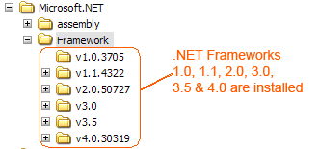

To install the .NET Framework, please go to the Microsoft website and install the latest version of the .NET Framework available for your operating system. At the time of writing it was .NET 4.6.

### 2.1.2. Install SQL Server 2008R2+

Install the appropriate version of the database software, following the instructions provided with the installation. Since KronoDesk is an enterprise-level software, we recommend SQL Server 2008 R2+, Web, Standard, or Enterprise editions. Express editions have limitations on Ram and CPU usage, and can cause significant performance issues. We also recommend enabling FullText indexing, as KronoDesk will take advantage of those extra indexes and dictionaries produced for faster searching and result pages for users.

### 2.1.3. Install Modern Browser

The KronoDesk UI is compatible with all modern browsers, but uses some HTML5 specific features on some pages, so on other third-party mobile browsers, some pages may not appear correctly.

### 2.1.4. Ensure that IIS is installed

On Widows Server installations, you may have to install the IIS Role if it is not already active.

On **Windows Server 2012+**, you need to click on Server Manager, then under the “Roles” heading, choose the option to “Add Role” followed by selecting the new role “Web Server / IIS”. Then click “Next” to bring up the role configuration screen:

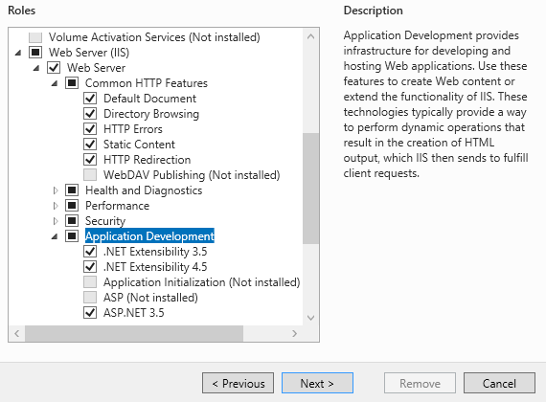

Make sure that the following features are enabled:

* Web Server (IIS)
  + Web Server
    - Common HTTP Features
      * Default Document
      * Directory Browsing
      * HTTP Errors
      * Static Content
      * HTTP Redirection
    - Application Development
      * .NET Extensibility 3.5
      * .NET Extensibility 4.5
      * ASP.NET 3.5
      * ASP.NET 4.5
      * ISAPI Extensions
      * ISAPI Filters
    - Management Tools
      * IIS Management Console
      * IIS Management Service
* .NET Framework 4.5 Features
  + .NET Framework 4.5
  + ASP.NET 4.5
  + WCF Services
    - HTTP Activation
    - TCP Port Sharing

To verify that this IIS is now installed, type [http://localhost](http://localhost/) into the address bar of Internet Explorer on your computer. You should see a screen displaying the initial IIS startup page:

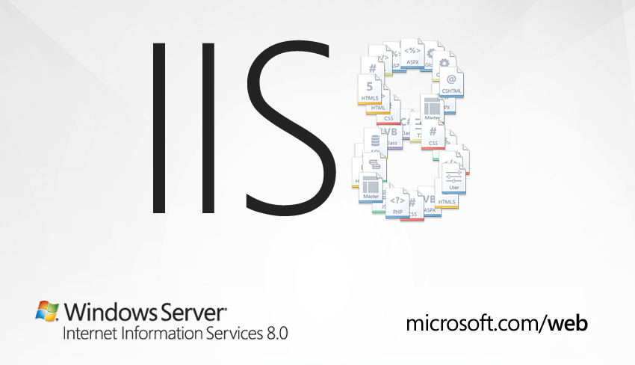

### 2.1.5. Ensure that ASP.NET is installed

Now that you have both IIS and .NET installed, you need to make sure that the Active Server Pages (ASP.NET) components that allow IIS to access the .NET framework have been correctly configured. If you installed .NET *after* IIS then ASP.NET is typically configured for you, but if you installed IIS afterwards, then further manual steps may be necessary. The settings are different depending on which version of Windows you are using:

To verify that ASP.NET has been correctly configured, click on Start > Control Panel > Administrative Tools > Internet Information Services (IIS) Manager to launch the IIS administrative console:

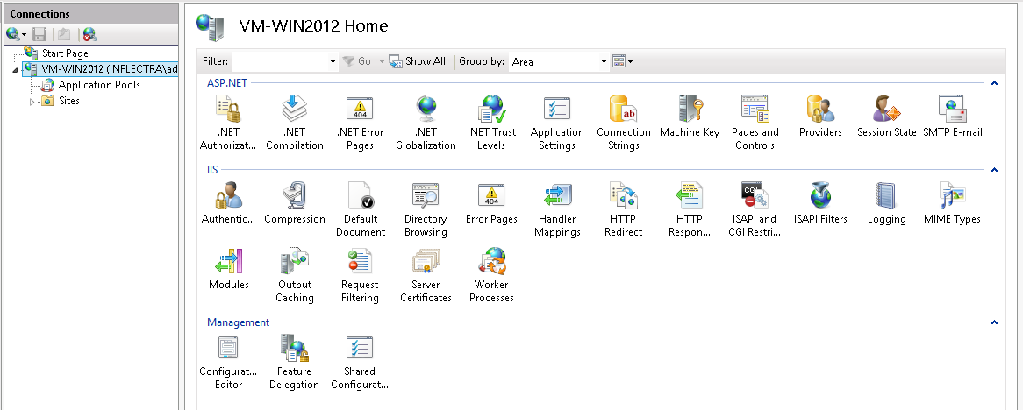

You should see a section called “ASP.NET” occupying the top third of the IIS screen. If not, then you need to go back to section 2.1.3 and make sure that you chose the option to install ASP.NET when installing IIS.

### 2.1.6. Ensure the Visual C++ 2015 Runtime is Installed

Make sure you have the Visual C++ 2015 Runtime installed (both the x86 and x64 versions). If you are not sure whether you have that installed or not, please go to <https://www.microsoft.com/en-us/download/details.aspx?id=40784> and download the x86 and x64 versions and try installing them. If they are already installed, the installer will let you know. We also provide a copy of the runtime in the CustomerArea of the Inflectra website.

## 2.2. Installing the Software

Now that all the prerequisites have been correctly installed, you are now ready to install KronoDesk® onto your system. To perform the installation, you will need the installation package downloaded from the Inflectra® website, the name of the organization that the software is licensed to, and the actual license key code which will be available in the customer area of the Inflectra® website.

To start the installation, double-click on the KronoDesk® installation package (it will have a filename of the form KronoDesk-v3.0.msi), and the Windows Installer will display the following dialog box:

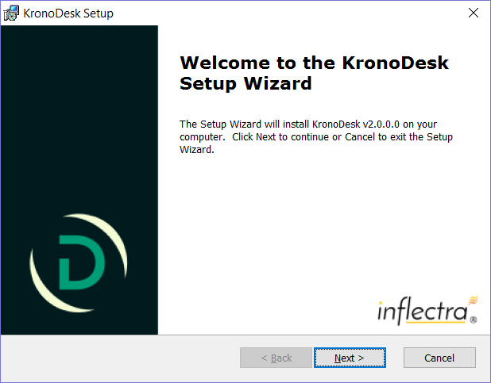

If you are upgrading from an earlier version of KronoDesk®, the dialog box will be similar except that it will instead let you know that you are upgrading from an earlier version to the current one:

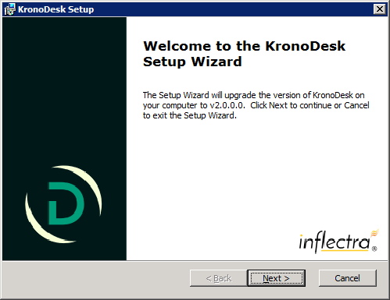

In this instance the installer will update the program files on your computer and migrate your data into the new version seamlessly. If for any reason you **don’t see the upgrade message** and you have an existing installation, don’t continue, but instead **contact Inflectra® customer support first**. This will ensure that your existing data is not overwritten by a clean install.

In either case, click the <Next> button to start the installation wizard which will gather information from you regarding how you want to setup the system, before actually installing the web-server files and database components. The next page of the installation wizard will display a list of all the required pre-requisites and whether the installer could find them or not:

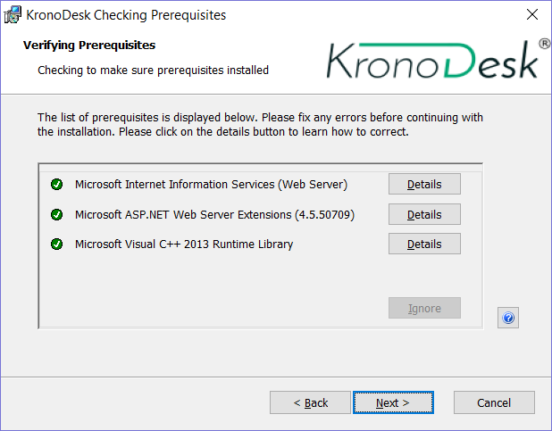

If any of the prerequisites were not correctly installed, the installer will display a red ‘X’ icon next to the missing component(s). If this happens, please refer to section 2.1 for installation of any prerequisites. If for any reason you have the prerequisite installed but the installer was not able to find it (this can occasionally happen on certain environments), click the <Ignore> button to proceed with the installation.

Once the prerequisites have been correctly installed, clicking <Next> will bring you to the next page in the installation wizard:

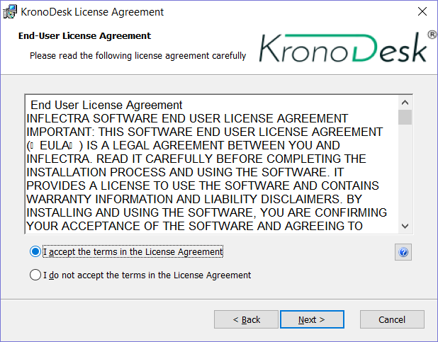

The next screen in the installation wizard outlines the KronoDesk® End User License Agreement (EULA). Please read this carefully as it describes the legal contract between you – the user of the software – and Inflectra® Corporation, the developer and publisher. Once you have read the agreement and understood your rights and obligations, select the radio button marked “I accept the terms in the License Agreement” and click the <Next> button.

The following screen will be displayed:

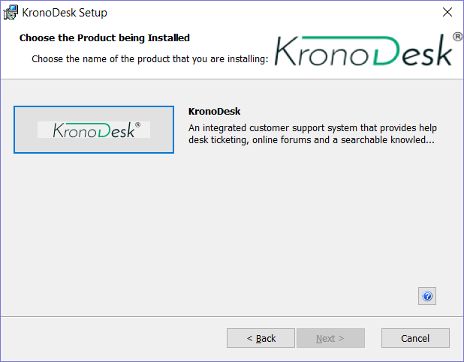

Click on the KronoDesk® button to confirm that you want to install KronoDesk. Once you have done this, the following screen will be displayed:

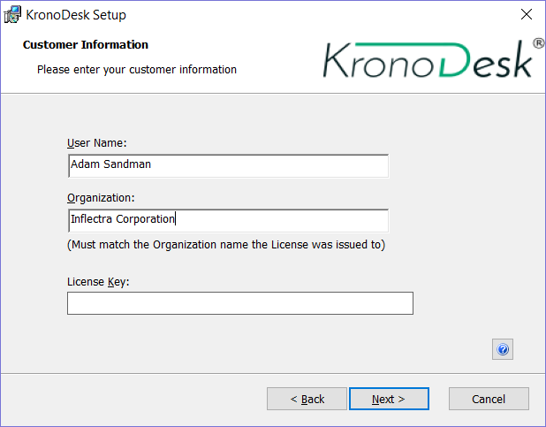

You need to enter your full name, the ***organization that was issued the software license***, and finally the full hexadecimal license key that was provided with the software. Once you click <Next>, the installer will verify that all three were entered, and that the license key matches the product being installed and that it matches the organization name. The installer will warn you of any discrepancies, but will allow you to proceed; however after installation, the system will not operate until a correct license key is entered.

If for any reason you are unable to get the provided license key to work, please contact Inflectra® customer support immediately and they will resolve the issue.

After clicking <Next>, you will be given the choice of installation to perform:

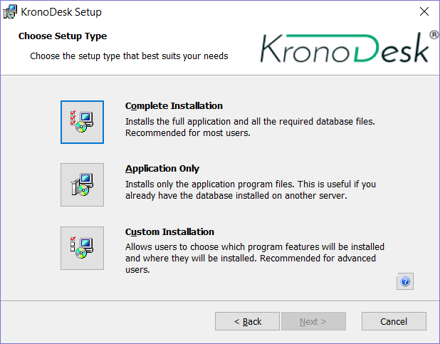

By default, the installer will install all of the KronoDesk® features onto the target system, so we recommend choosing “Complete Installation”, which will both install the complete system – application and database. For advanced users who want to change the folder to which the system is installed (by default it is C:\Program Files (x86)\KronoDesk), change the name of the database created (by default it will be KronoDesk) or to prevent the installation of the optional web-services data integration modules, you can choose the “Custom Installation” option, which allows you to change those settings prior to installation.

The “Application Only” installation is useful when you need to move the application to a different server, but want to leave the database installed on the same server. In this case you can use the “Application Only” installation on the new server, and once the installation is completed, change the name of the database pointed to in the “web.config” file to the existing database server.

This manual assumes that the “Complete Installation” option is chosen, in which case the following screen is displayed:

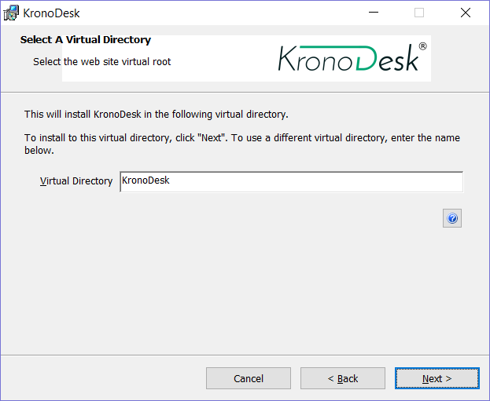

This screen allows you to change the name of the web-site URL that will be user to access the system. By default, users would need to type into their browsers: http://<server name>/KronoDesk. Should you want to have a different name – other than KronoDesk – change the name in the Virtual Directory box, otherwise simply accept the default name and click <Next>. Note: The installer will check to make sure that the name you have chosen is not already in use, and will warn you if it is.

Upon clicking <Next>, you will be taken the database connection screen:

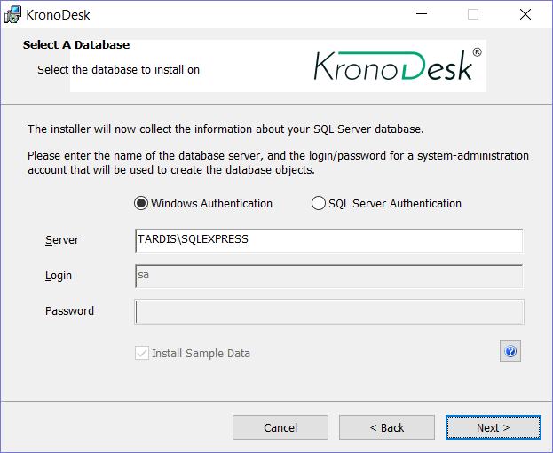

You can connect to the SQL Server database using either Windows Authentication or SQL Server Authentication, and the process is slightly different for each mode:

### 2.2.1. Windows Authentication

This is the easiest option when the application and database will be residing on the *same* server. In this case, choose the “Windows Authentication” option and the Login/Password boxes will be disabled. In this case, the installer will connect to the database using your current Windows login to create the application database objects, and KronoDesk® will connect to the database during normal operation using either the ASPNET or NETWORK SERVICE Windows accounts (it depends on the version of the operating system).

### 2.2.2. SQL Server Authentication

This is the recommended and easiest option when the application and databases will be residing on *different* servers across the network. In this case, choose “SQL Server Authentication” and provide a SQL Server Login that has Database Owner (DB-Owner) permissions – e.g. the built in System Administrator (SA) account. The installer will use this DB-Owner account to create the database objects, and KronoDesk® will use a special login (called KronoDesk by default) for normal application operations.

For either mode, in the “Server” box, you need to enter the name of the Microsoft SQL Server instance that is running on your system; the installer will default it to the hostname of the server (which in many cases will be correct). The easiest way to find out the database server name is to open up the SQL Server Administrative console (typically by clicking Start > Programs > Microsoft SQL Server > Enterprise Manager) and look for the name of the server.

Once you have entered the various pieces of information, click <Next>. The installer will attempt to connect to the database using the provided information, and it will display an error message if any of the information is incorrect. Assuming the information is correct, the following screen will be displayed:

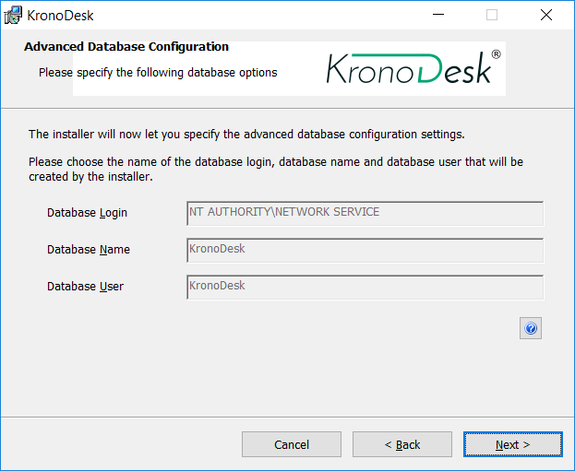

This page lets you customize the name of the database login, database name and database user that the application will create. If you chose the “Custom Installation”, then the fields will be editable, otherwise they will be read-only. Also if you chose “Windows Authentication” then the Database Login field will be set to the built-in Windows account associated with ASP.NET for the specific operating system being installed on (and cannot be changed). Once you have reviewed this page and made any changes, you should click <Next> to proceed:

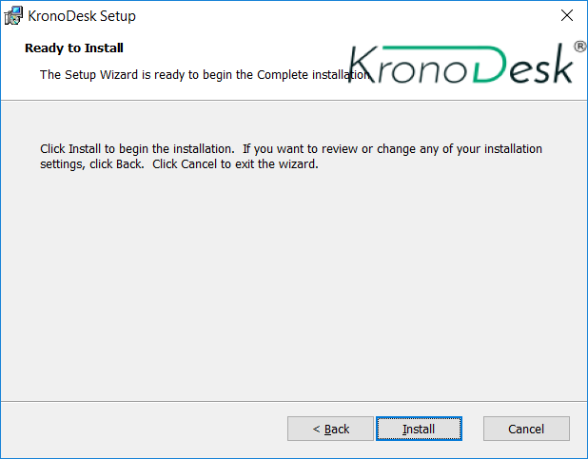

Click the <Install> button to actually begin the process of installing KronoDesk® onto your system. If you are installing KronoDesk® onto Windows Vista (or later), then you will first be prompted by the Windows User Access Control (UAC) security system to confirm that you want to install a new piece of software. Click the option that confirms you want to proceed with the install.

The installer will then display a progress bar that gradually fills as the installation proceeds:

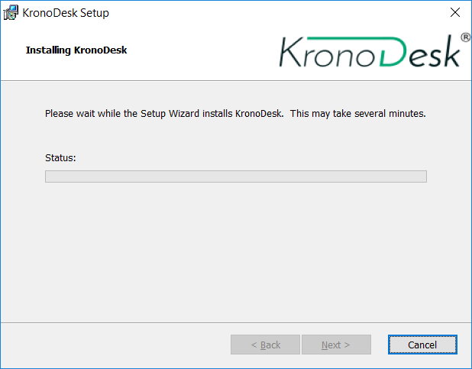

Once the installation is complete, the following message will be displayed:

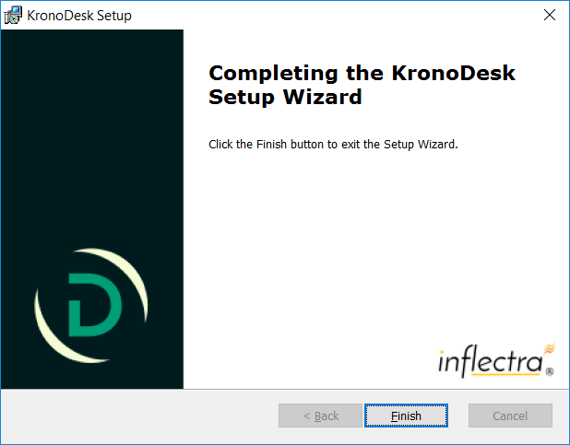

Congratulations! You have successfully installed KronoDesk® onto your system. If you type <http://localhost/KronoDesk> into your browser you should see the KronoDesk® home page, as illustrated in the *KronoDesk*®*User Manual*. If for any reason you don’t see the home page, please refer to *Appendix A – Troubleshooting IIS* or contact Inflectra® Technical Support using one of the methods described at our website <http://www.inflectra.com/Support>.

The default login/password for accessing KronoDesk is:

* Login: administrator
* Password: PleaseChange

## 2.3. Security Considerations

It is important to note that by default, all web pages served by IIS using the HTTP protocol are unencrypted, and as such, the usernames and passwords used by KronoDesk® to log into the application can be read by network sniffing tools. If you are using KronoDesk® purely within an intranet environment, this may not be an issue. However if you are externally hosting KronoDesk® onto a publicly accessible website, we recommend installing a Secure Sockets Layer (SSL) encryption certificate, and restricting all web-traffic to the secure HTTPS protocol instead. For details on how to perform this task, please refer to *Appendix B - Installing an SSL Certificate*.

# 3. System Administration

Now that you have successfully installed KronoDesk®, this section of the guide outlines how to perform the typical system-wide administrative tasks necessary for setting up projects in the system, managing users and verifying the license information. To perform these tasks, you need to login to the system with a user that is a member of the “Administrator” role. The special “administrator” login is created by the installer for this very purpose. You should initially login to KronoDesk®with the username administrator, and the password PleaseChange. **It is recommend that this password be changed as soon as possible** to something that is secure yet memorable by clicking on the “User Profile” link – see the KronoDesk®User Manual for more details.

Once you have logged in as an Administrator, you need to click the “Administration” link in the main navigation bar. This will display the Administration home page:

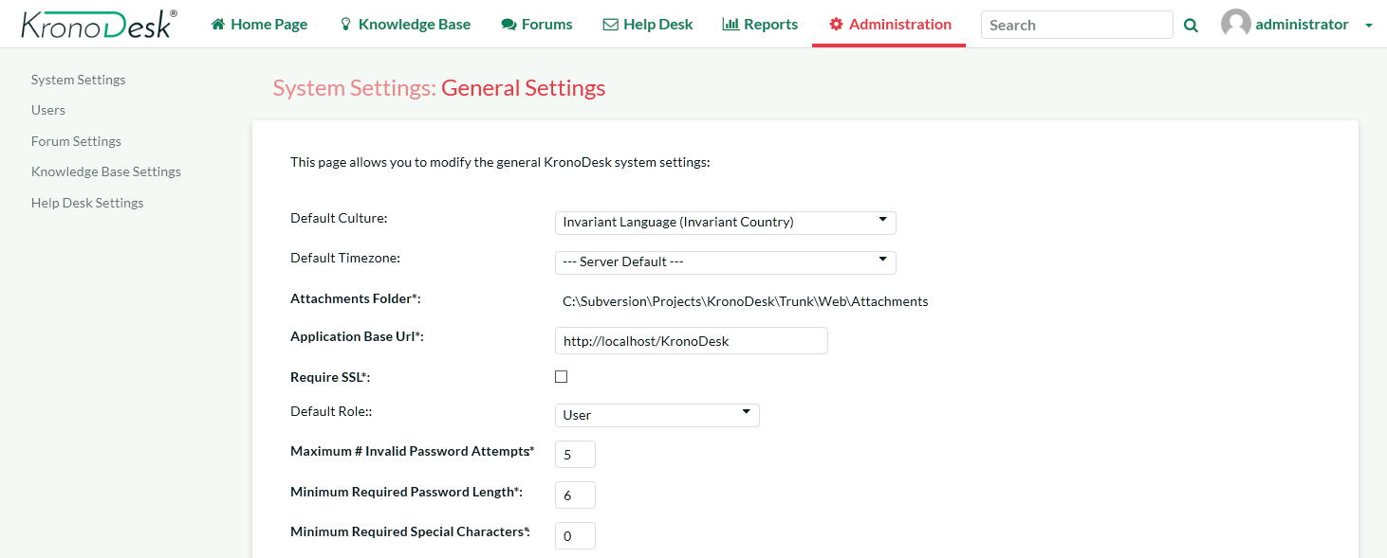

The page displays a list of the various administration settings pages categorized by the part of the application they relate to. You can expand and collapse the administration group by clicking on the green header bar. By default, the administration home page will display the System Settings > General Settings page described in section 3.1.1 below. Each of the other administration settings pages is described separately below.

## 3.1. System Settings

This section contains all of the application-wide settings that affect the entire system, rather than a specific module. The only exception is that the settings related to authentication and user management are in their own separate group “User Settings”.

### 3.1.1. General Settings

The General Settings page is used to set the general application-wide settings that affect the overall application and are used to ensure that the application matches your environment. In the current version, you can specify the default language, specify the base URL, configure the folder used to store document attachments and also specify whether certain parts of the application should require a secure connection.



This page lets you specify the following values:

* **Default Culture** - KronoDesk can display information in a variety of different languages (assuming that the appropriate language packs have been installed) and number formats. By default, KronoDesk will use the regional settings (language and number formats) of the operating system it has been installed on. However, you can override this default by choosing the appropriate culture from the list of options displayed in the drop-down list. *Note: The list of culture options does not reflect the available language packs, so in some cases, the setting will only change the number formats.*
* **Default Time Zone** - KronoDesk stores all dates and times internally in Universal Coordinated Time (UTC) and can therefore display dates/times adjusted for different time zones. By default, KronoDesk will display dates in the time zone specified in the operating system it has been installed on. However, you can override this default by choosing the appropriate display time zone from the list of options displayed in the drop-down list.
* **Attachments Folder** - By default when KronoDesk is installed, the document attachments uploaded in the system get stored inside the C:\Program Files\KronoDesk\Attachments folder located inside the main KronoDesk installation root. However you may want to have the documents stored on a remotely mounted drive or on a different hard disk partition. In which case you can simply change the folder pointed to in the text-box illustrated above and then click [Save] to commit the change. When changing the directory, be sure to move any existing attachment files to the new location, and verify that the IIS User has read and write access to the directory.
* **Application Base URL** - This is the URL that your users use to access the system. Do not put the /Login.aspx or any other page here, as this URL is used to generate links to different pages in the application. This setting is primarily used in email notifications and RSS feeds to specify the URL of the application.
* **Require SSL** – When this is selected, the application will require a secure connection when accessing the Account Profile pages. This is useful if you want to run the site using an unencrypted connection (to maximize performance) but want to require a secure connection for the login pages where a user will have to enter a password. Using this option requires that you have a Secure Sockets Layer (SSL) certificate installed on your web server.
* **Use SQL Free Text** – If possible, when running searches and queries, have the application use SQL’s Free Text indexing to speed up result pages to users. Note that enabling Free Text Indexing will require higher minimum system requirements for the SQL Server.
* **Allowed Domains** – This is used when accessing the KronoDesk REST API from another web page using a Cross Origin Request Sharing (CORS) based REST request. In KronoDesk you need to specify the allowed domains (or * for all) which are allowed to make sure a request.
* **Authoritative Domain/Protocol** – In case where multiple domains point to the same installation (i.e. www.kronodest.net and kronodest.net), any access to the application will redirect to the domain and protocol entered here.

### 3.1.2. Enabled Sections

This section allows you to activate and deactivate different parts of the application (for example you might not want to initially make the support forums available to customers). Changes take effect immediately, and no data is lost. You can enable the sections at a later date, and still have all of your information from earlier. You are still able to adjust settings for a disabled section in Administration, but none of the changes will be visible until the section is re-enabled.

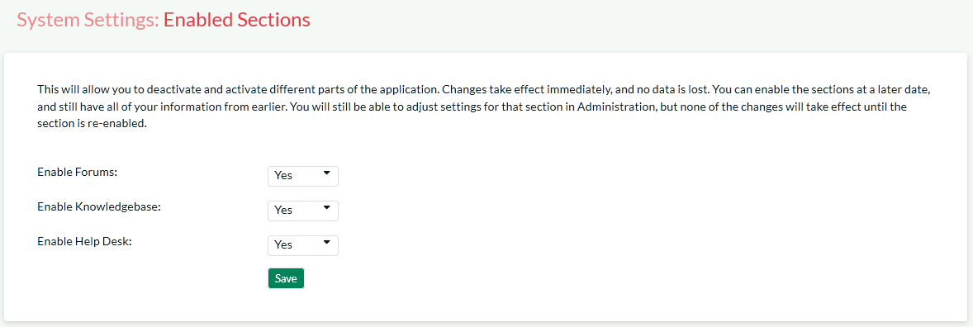

### 3.1.3. Appearance

The Appearance page is used to customize the information displayed in KronoDesk and edit the colors and theme of the application.

#### 3.1.3.1 Theme Tab

The first tab lets you select a pre-generated theme to use or create a new theme or edit an existing theme.

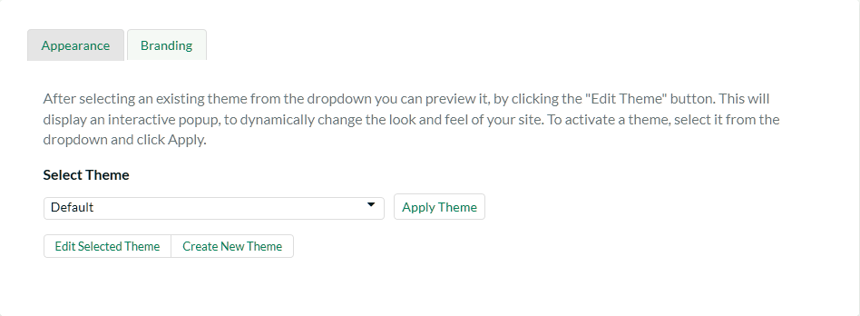

On this tab, you can select and ‘Apply’ the theme you want to use for the application. Or, if you select ‘Edit Selected Theme’ or ‘Create New Theme’, you will be taken to the theme edit window:

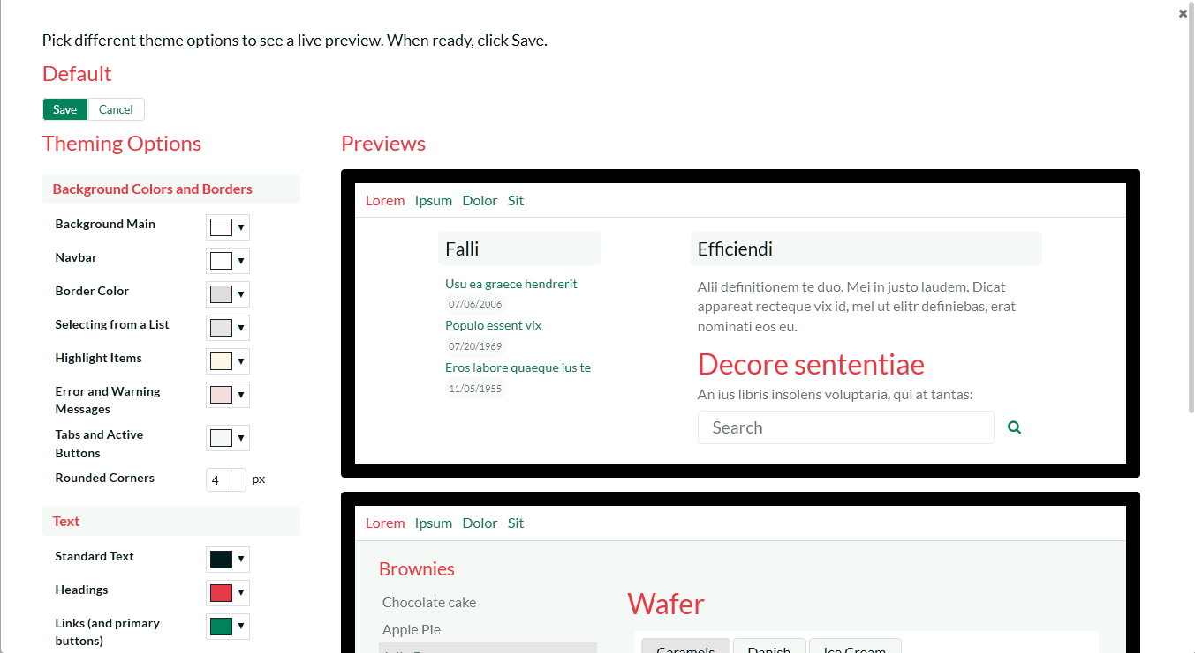

By selecting the colors in the selection boxes, the live preview window will update to show how the actual application will work, using a sample page. Once you have your design configured, click the ‘Save’ button to return to the theme selection. Then, click the ‘Apply Theme’ button to apply the designed theme to the whole application. **Do not** set all colors to the same value! Your users will not be able to navigate the site.

#### 3.1.3.2 Branding Tab

This tab is where you can specify static information relating to your company, external links and other fixed-page items.

This page lets you specify the following values:

Images:

* **Company Logo** – This is the image that is displayed in the top left corner of the navigation bar, on wider devices. (Desktops, tablets in landscape mode, etc.)
* **Mobile Logo** – This is the image that is used in the top left corner on smaller devices.

Company Information:

* **Company Name** – This field is used to change the name of the company that is displayed in the application footer
* **Copyright Year** – This field is used to change the copyright year to match the starting year of your company’s website copyright.
* **Contact Phone Number** – This field is used to specify the phone number that should be displayed on the application footer
* **Email Address** – this field is used to specify the email address displayed on various pages within the application. We recommend that you set this to match your primary support email address (e.g. [support@mycompany.com](mailto:support@mycompany.com) or [info@mycompany.com](mailto:info@mycompany.com)).
* **RSS Feed** – The application home page will display a list of recent news headlines from your company’s newsfeed. To enable this functionality, simply enter the URL for your company’s RSS newsfeed into this text box and it will automatically enable the home page widget and tell it to display news items from your newsfeed.
* **Title Prefix** – All of the web pages in KronoDesk prefix the title of the page with the application name (e.g. “KronoDesk | Help Desk” or “KronoDesk | Support Forums”). This setting allows you to choose the text displayed in the prefix. We recommend we set it to your company’s name. That way, web pages will be displayed using this name (e.g. “MyCompany | Help Desk”).

Hyperlinks:

* **Header Icon Link** – This is the URL to take the user to when they click the company logo.
* **Useful Link #1 - #3** – These are the names (text) and the URLs to display to the user. These can be used in Email templates for notifications going out to users, and are displayed on the customer’s home page.
* **Footer Link #1 - #3** – These are the names (text) and the URLs to display to the user. These are displayed in the footer of the application.

Page Texts:  
This is a list of links to pages that have inline editors to edit and adjust how the pages look to users viewing the pages.

Page Javascript:  
This allows the administrator to add some script to execute on every page. All pages will run the Javascript entered here, except for Administration pages. This would be used to enter in Analytics trackers or other SEO or ROI tracking code.

### 3.1.5. Email Configuration

This section allows you to change the settings regarding how KronoDesk sends out email notifications. There are several tabs that you contain different settings:

#### 3.1.5.1. Email Options

This tab allows you to change some of the basic high-level email settings:

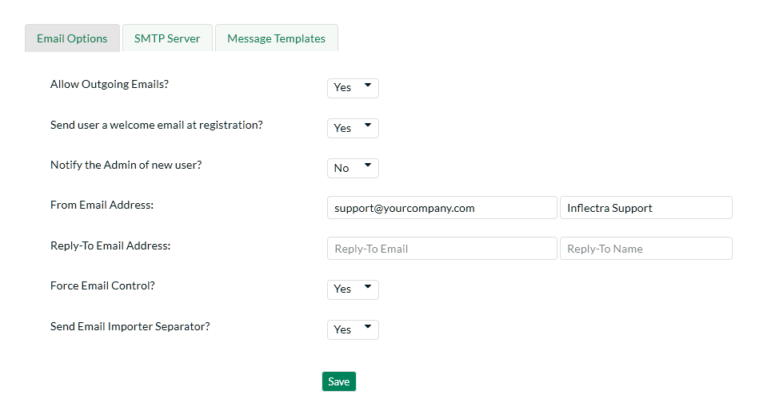

The options are:

* **Allow Outgoing Emails:** Turning this off will disable ALL outgoing emails. Note that with this off, the email importer cannot be used, as users created via the importer will not be able to verify their account.
* **Send User Welcome Email:** When this is enabled, a new registered user will receive a welcome email.
* **Notify Admin of New User:** When enabled, the administrator account will be sent an email notifying of a new user registration.
* **From Email Address:** On outgoing emails, this name and address is the email account the email will come from.
* **Reply-To Email Address:** On outgoing emails, this name and address will be in the ‘Reply-To’ header of the email.
* **Force Email Control?:** This setting lets the users define their own email options. If enabled, then users will not be able to disable receiving emails from the application. If disabled, they will be able to turn off email notifications.
* **Send Email Separator:** Recommended if using the Email Importer for importing support tickets from an email account. Enabling this will add a line that will help the Importer keep reply text as minimal as possible.

#### 3.1.5.2 SMTP Server

This page allows for setting up KronoDesk to communicate with your SMTP Server. The fields available and their usage are:

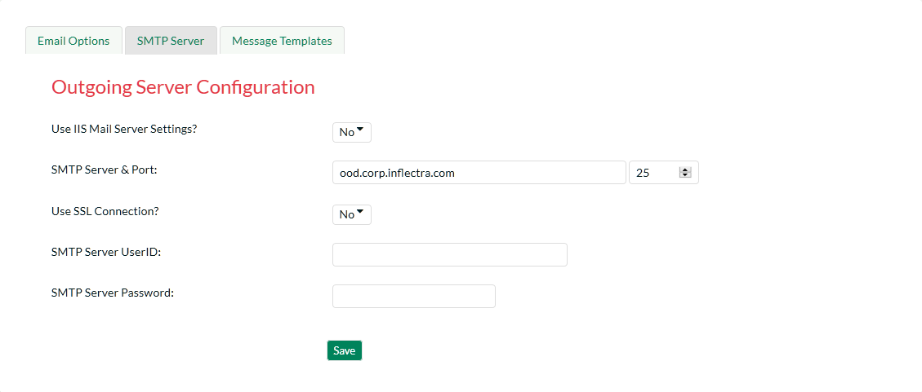

The options are:

* **Use IIS Mail Server Settings**: If set to ‘No’, you must define your SMTP server information below. If set to ‘Yes’, the application will use the defined IIS virtual server settings.
* **SMTP Server Hostname / Port**: The DNS or IP address of the SMTP server, and the port that it accepts incoming mail on.
* **Use SSL Connection**: Whether or not the SMTP server requires an SSL connection.
* **SMTP Server UserID / Password**: The username or password to log onto the SMTP server with. If no username or password is required, enter in ‘anonymous’ in both fields.

#### 3.1.5.3 Mail Templates

This tab allows you to customize the email templates that are sent out:

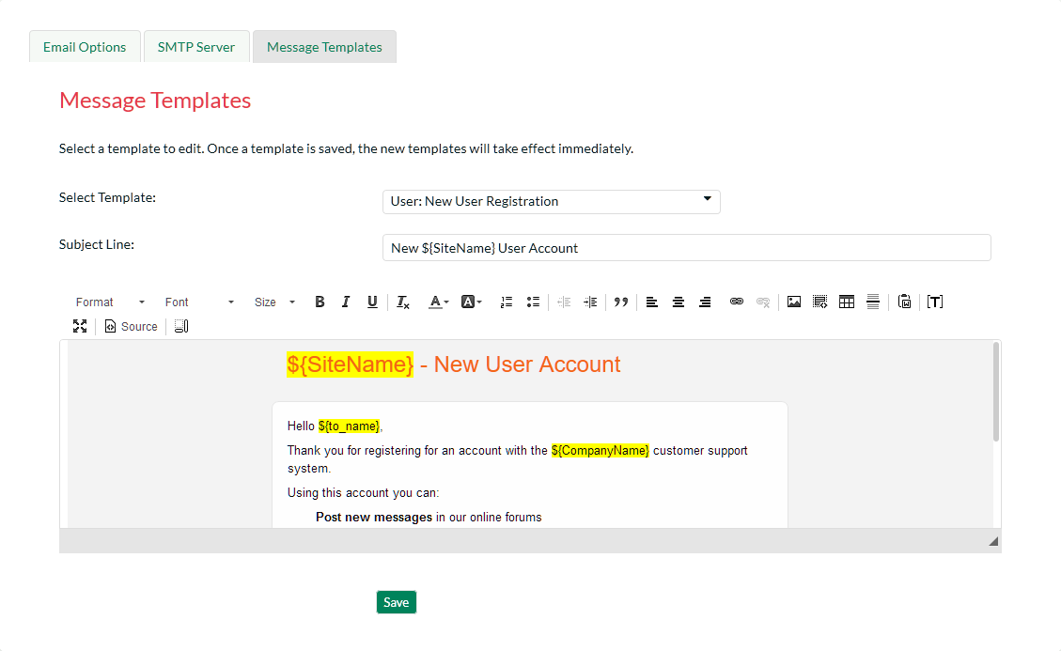

To modify a template, you need to select which template you wish to edit. Once you select the template, the page will reload and display the selected template. The subject line is used in all emails sent with this template – note that some templates do not have a subject defined, and in this case the field will be hidden.

With this editor, you can link to external images, but cannot send any images as attachments.

You can modify the template to make it match your company’s styles, adding colors and fonts as needed.

Outgoing data uses a Token system. You can select a token to insert using the Token button in the toolbar of the rich text editor (**[T]**). It will open a dialog letting you select the token to insert.

Available templates to edit are:

* **User: New User Registration**: If the ‘Send new user welcome email’ setting is set to true, this email template is sent out when a user registers.
* **User: Forgot Password**: When the user forgets their password.
* **Forums: Subscription**: Sent when there is an update to a forum that the user is subscribed to.
* **KB: Subscription**: Send when there is an update to a Knowledge Base Article that the user is subscribed to.
* **User: Inactive Account Created**: Sent out when a user had an account created for them via the Email Importer application. Contains information on how the user can verify their account to be able to log into the website.
* **Ticket: Notification**: Sent out when a notification event is fired off due to a ticket update. This is the master template – the template can be edited per notification event when the event is created.

### 3.1.6. Custom Lists

Custom Lists at this time are used in Custom Field definitions. The main custom property list screen lists all available lists available for assignment to a custom field.

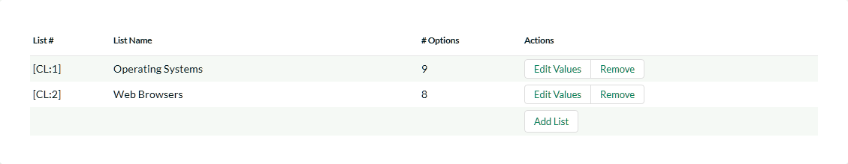

The table shows all defined custom lists and their information. The Custom List ID, the name of the list, how many selectable options it has, and then actions you can perform on the list – Edit the Values, Remove (delete) the list, or add a new list. Lists must have a unique name.

When creating or editing a list, the following screen is displayed:

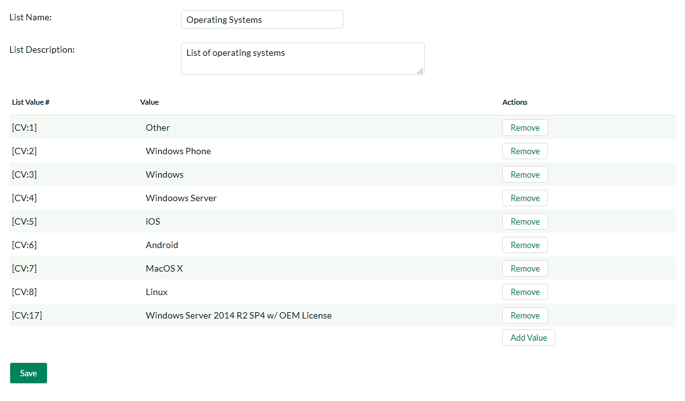

The list name and description are for identification purposes only, and are not visible to other users in the application. Each list item must have a unique name, if you try to add a duplicate or empty value, an error will be thrown. Click the ‘Save’ button to save your values, and use the link at top to return to the main Custom List page.

### 3.1.7. Product Definitions

Products are used throughout the system in various ways. For tickets and in the knowledge base, they are used to classify and for organization, and to help the user find information they need to help them. The screen for editing and creating products is:

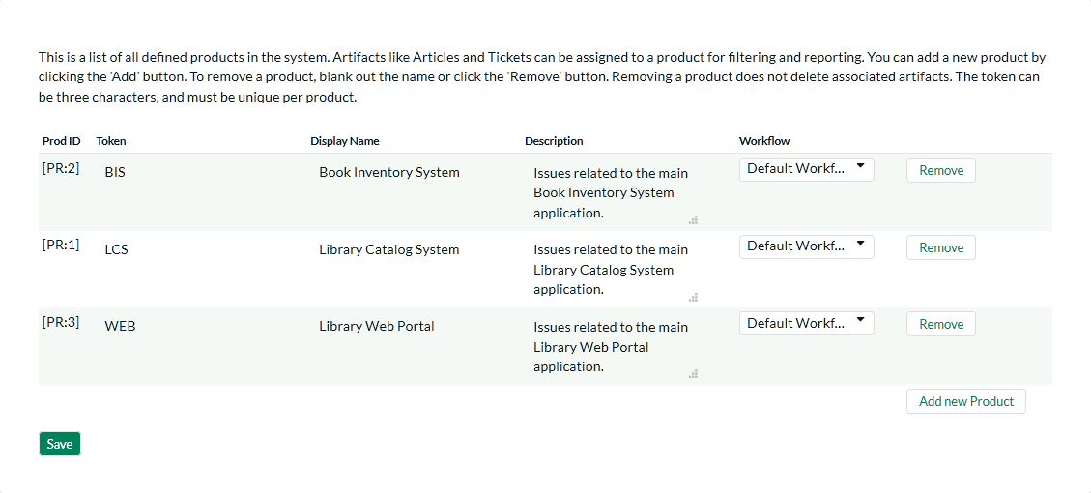

The fields are used as follows:

* **Token**: Not used at this time, however, each product must have a unique token ID.
* **Display Name**: This is what the product will display to users when selecting or researching a product.
* **Description**: This is a short description for internal use to describe the product.
* **Workflow**: This is the selected workflow for Tickets assigned to this product. See Workflows, below.

### 3.1.8. License Details

The license details page displays the information about the installed license for the particular instance of KronoDesk® being used. The information displayed includes: the product name, the license version (e.g. v2.0.0.0), type of license in effect (x-user fixed, x-user concurrent, demonstration, enterprise, etc.), the organization that the license belongs to, the actual license key code and finally the number of agent-users concurrently logged-in. This last piece of information is useful as it helps administrators track down how many agent licenses are being used.

A sample page is illustrated below:

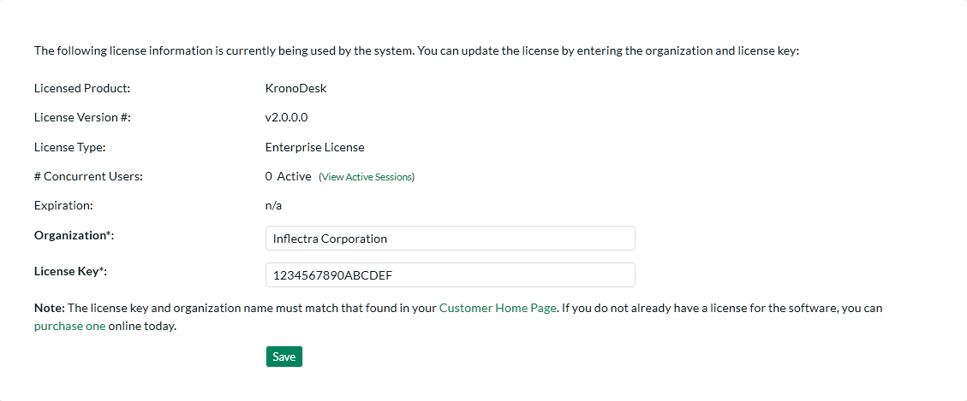

To change the license key used by the system (for example, if to upgrade from Trial edition to Standard edition), you do **not** need to reinstall KronoDesk. All you need to do is simply change the information in the **organization** and **license key** text-boxes to match the license key and organization name found in the customer area of our website (<http://www.inflectra.com/CustomerArea>) and click the <Update> button.

If there is an issue with the license key (e.g. a trial version that is passed its expiration date, or where the license key doesn’t match the organization name) an error will be displayed describing the specific issue with the information you entered. If you are unable to get the system to work with the license key information, please contact Inflectra® customer support at: [support@inflectra.com](mailto:support@inflectra.com).

### 3.1.9. Event Log

The “System Event Log” administration page lets you view all of the errors, warning and other diagnostic messages that have been logged in the system:

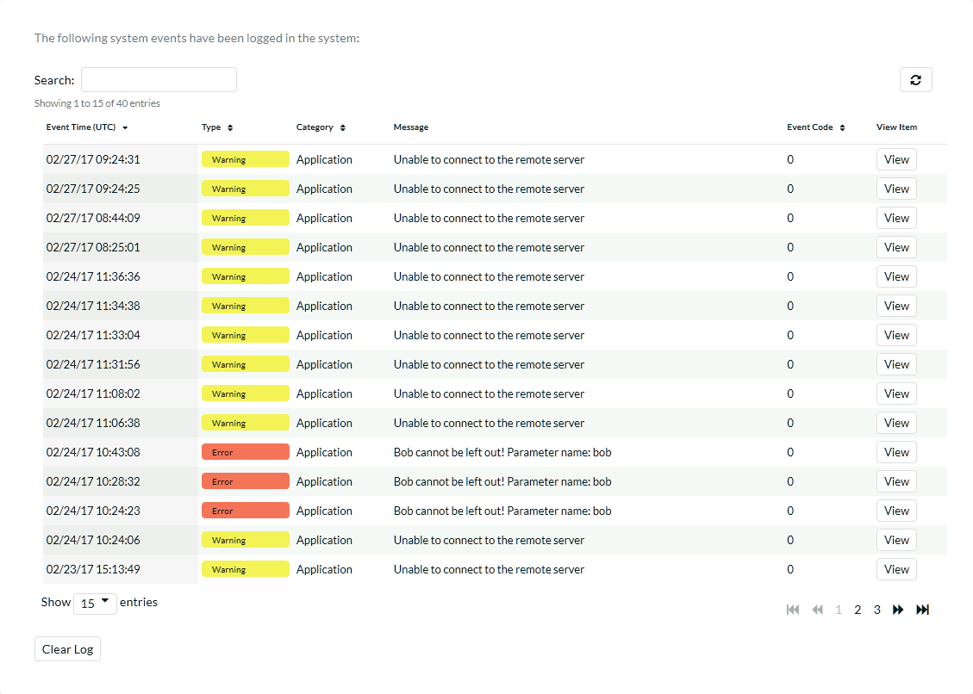

Each event entry is displayed along with the date-time it occurred, the type of event (error, warning, information, success audit, failure audit), category (application, source code provider, data-synchronization) and the short name. To view the full details of the error or warning, click on the “View Item” button:

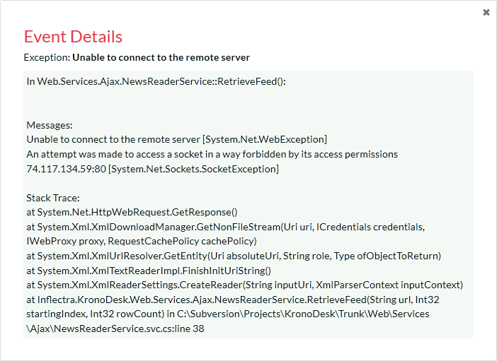

The popup dialog box will display the full error message log and stack trace in a moveable dialog box. This information should be provided to Inflectra customer support if you log a help desk ticket.

### 3.1.10. Remove Sample Data

This administration link is only available while the system still has sample data in it. This administration option will remove all data that was added in at installation, with the following guidelines:

* **Users**: All users between ID 2 and ID 11 will be removed. The main Administrator account, and any users created after installation will remain.
* **User Organizations**: The two sample organizations will be removed.
* **Tickets**: All tickets created at installation will remain, except for the first 28 tickets which were installed
* **Ticket Statuses, Priorities, Resolutions, and Types**: All these will be removed, unless any are used in tickets that were created after installation.
* **Custom Property**: All custom property definitions for Tickets will be removed.
* **Attachments**: All attachments created at installation will be removed.
* **Articles**: Articles 1 to 28 will be removed.
* **Products**: All predefined products will be removed, unless they are in use by any tickets not removed.
* **Categories**: Categories 1 through 4 will be removed, including all forums and threads contained therein, even if they were added after installation.

This can only be run once, and cannot be undone without reinstalling the entire application, so please **use with caution!**

Some sample data will remain, depending on what data was added before the remove action was run. Depending on the data, there may be some foreign links in the database that will prevent some sample data from being removed.

### 3.1.10. Orphaned Documents:

In some occasions, there can be attachments stored on the system that are not deleted when their associated item is deleted. This can cause unused files to fill up the attachments storange directory. This page will show the administrator any attachments in the database that have no associated link to a ticket or KB article, or documents on the file server with no record in the database:

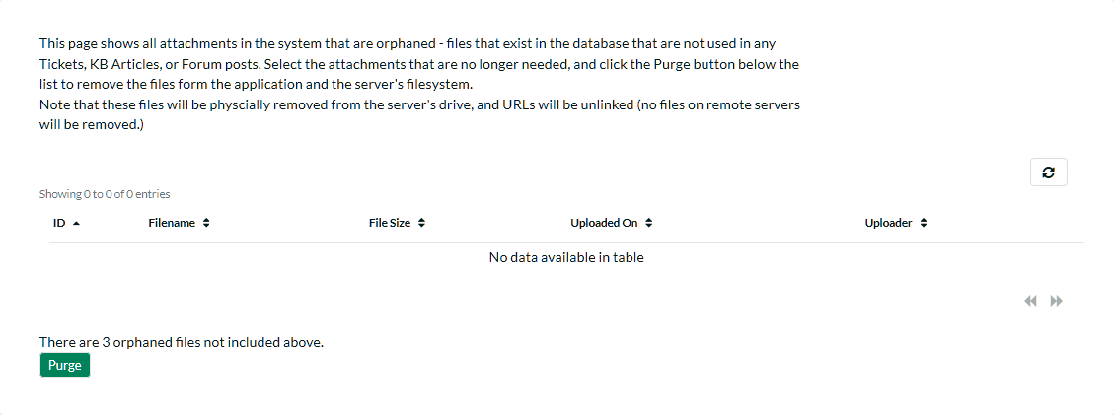

By clicking the ‘Purge’ button, the system will be cleaned of all unused files and unlinked attachments.

## 3.2. Users

This section contains all of the settings related to viewing and managing users in the system. Currently it allows an administrator to view the list of users and modify a user’s profile as well as see a list of active sessions.

### 3.2.1. User Security

This page shows options for configuring user registration and login options. By adjusting the settings here, it is possible to require all users to verify email addresses, turn off new-user registration completely, and require administrator approval of all new users:

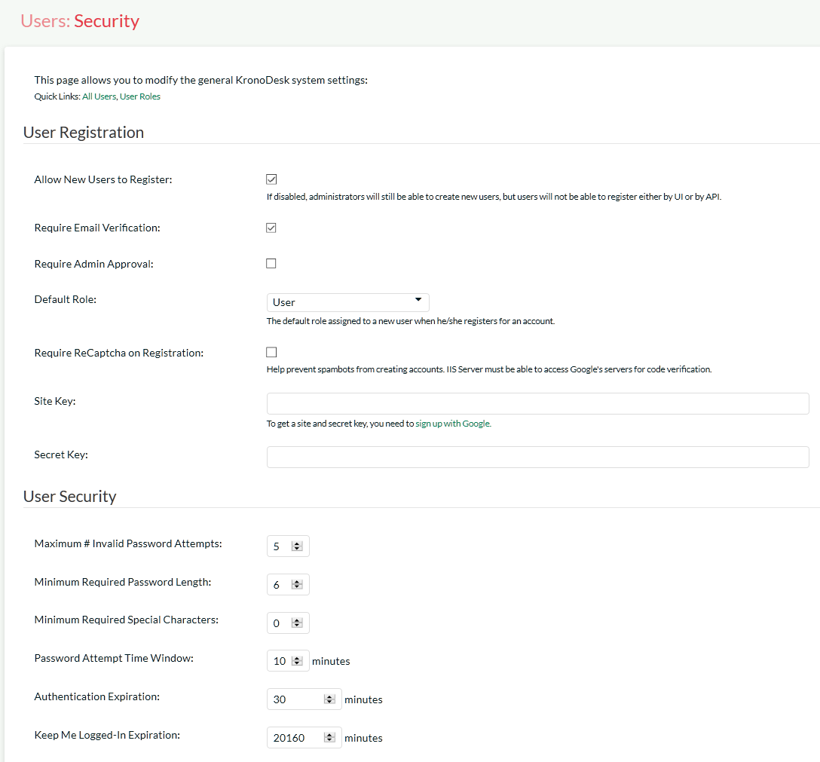

Available options are:

* **Allow New Users to Register** – When disabled, new user creation will not be possible, except by an administrator.
* **Require Email Verification** – Sets whether users must verify their email addresses before they will be allowed to log into the system. They will still be able to access the site as a guest, however.
* **Require Admin Approval** – Sets whether all new accounts created will need to be verified by an administrator account.
* **Default Role** – When a new user registers to access your instance of KronoDesk you have an option of assigning them a default role in the system.
* **Require Captcha on Registration** – Sets whether the user must pass a bot/robot check while creating a new account.
* **Site / Secret Key** – Required for the ReCaptcha validation. These are issued by Google (<http://www.google.com/recaptcha/admin>), and must be entered in for the bot-check to activate.
* **Maximum # Invalid Password Attempts** – Set this to the number of times a user can enter an incorrect password before their account is temporarily locked out. This is important in preventing ‘brute force’ password hacking attempts.
* **Minimum Required Password Length** – Set this to the minimum length of passwords in the system. Choosing a longer password will make it harder for an unauthorized user to crack a password and gain entry into the system.
* **Minimum Required Special Characters** - Set this to the minimum number of non-alphanumeric characters that will be required for passwords in the system. Choosing more required special characters will make it harder for an unauthorized user to crack a password and gain entry into the system.
* **Password Attempt Time Window** – Set this to the duration (in minutes) after which a user’s account will be automatically unlocked (due to repeated incorrect password attempts).
* **Authentication Expiration** – This specifies the amount of time (in minutes) after which a user will be logged out due to inactivity when they login without choosing the ‘Remember Me’ option.
* **Keep Me Logged-In Expiration** - This specifies the amount of time (in minutes) after which a user will be logged out due to inactivity if they have chosen to login with the 'Keep Me Logged-In' option. This should normally be longer than the previous setting.

### 3.2.2. Manage Users

This page will display a list of all the users (both active and inactive) currently in the system:

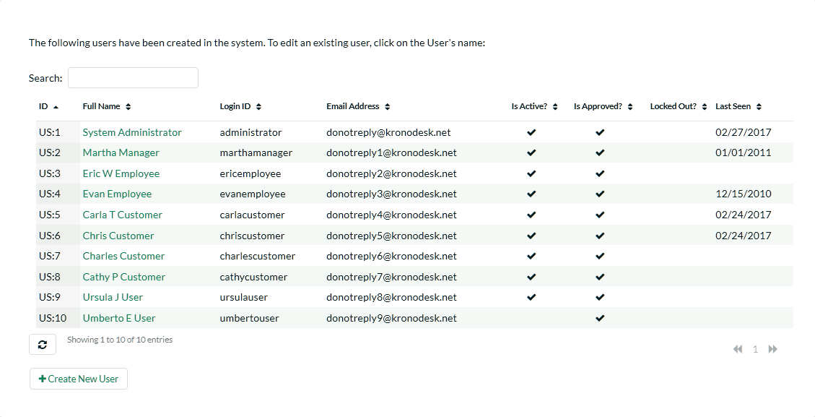

The users are listed with their name, login, email address, active status, approved status, whether they are currently locked out (for incorrectly entering their password too many times), the date they last logged-in and their user id. You can sort or filter the user list by entering the text in the search box. To view the details of a specific user, simply click on their name which is a hyperlink:

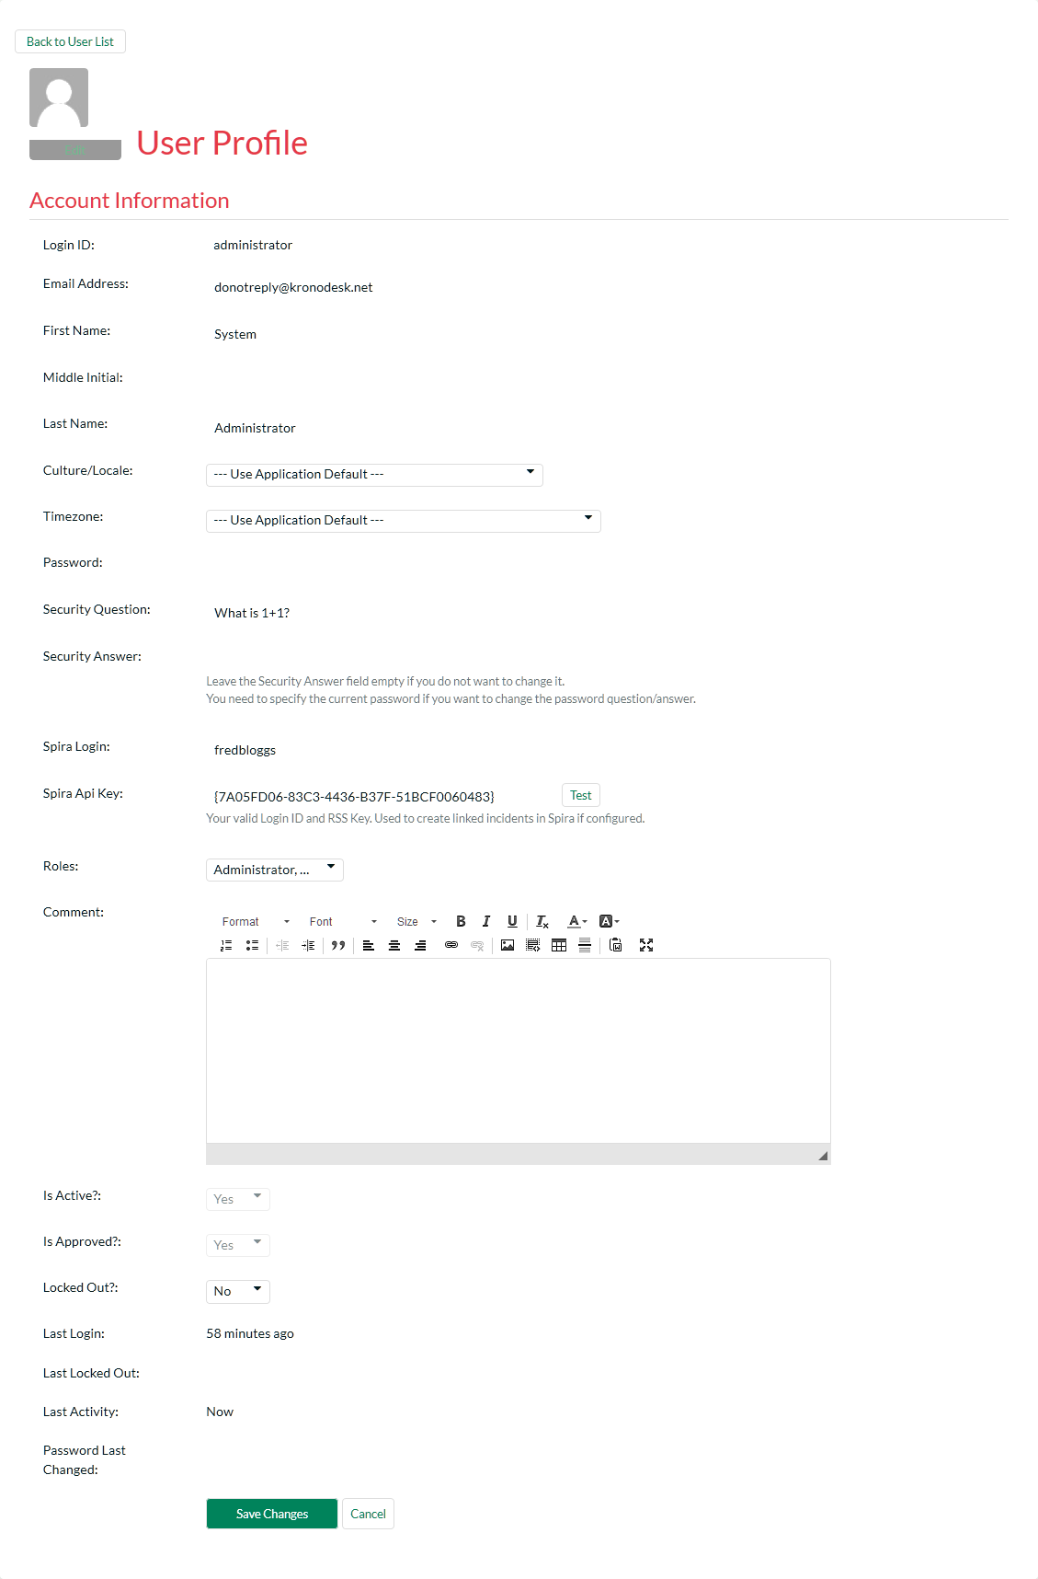

You can update the following fields on this page:

* **Email Address** – a valid email address that notifications will be sent to. This has to be unique.
* **First Name** – the user’s first name
* **Middle Initial** – the user’s middle initial (if applicable)
* **Last Name** – the user’s last name
* **Comment** – Used for Admin purposes only, the user does not see this on his own account.
* **Culture/Locale** – By default all profiles will be set to use the application’s default culture. This means that the language and number formats used in the application will be the ones decided by the person who installed the system. However there are cases where you want to use a different language or number format (for example, a German employee working in the German office of a French company might want to use the German culture instead of French). You can change the culture to any of the options listed in the dropdown list.
* **Time zone** - By default all profiles will be set to use the application’s default time zone. This means that the time zone used in the application to accept/display data will be the one decided by the person who installed the system. However there are cases where you want to use a different time zone (for example, a German employee working in the German office of an American company might want to use CET instead of EST). You can change the time zone to any of the options listed in the dropdown list.
* **Password** – if you want to change the user’s password, you can enter it in the text box. If you don’t want to change the password, you can leave this blank.
* **Security Question/Answer** – if you want to change the user’s challenge question/answer, enter a question that only they will know the answer to, together with the matching answer to that question. If you don’t want to change the question/answer, you can leave these blank.
* **Roles** – this displays a list of the available roles in the system, with the ones that the user belongs to selected. You can change the roles by selecting them in the dropdown list.
* **Spira Login/API Key** – If you have your KronoDesk install linked up with a Spira install to keep track of development bugs and fixes, entering the user’s login and API Key here will allow this user to create and view incidents related to the ticket the user is viewing. Note that these fields are only available for Internal users, and when Spira integration is enabled.
* **Active?** – Used to specify whether this user account is active or not.
* **Approved?** – Used to specify whether this user account is approved or not. Currently all users in the system are created with approved accounts.
* **Locked Out?** – Used to specify whether this user account is temporarily locked due to the user making too many incorrect login attempts.
* **Avatar** – Each user in KronoDesk can have a small graphic icon (an avatar) associated with their account. This icon will be displayed next to forum posts, ticket comments, etc. You can click on the [Browse] button to change their avatar or [Remove] to switch their user back to the default image.

Once you are satisfied with the changes, you can click [Update User] to commit the changes. If there are any validation errors, they will be displayed, otherwise the system will display a confirmation box.

Log In As User - This button will log you out of you own account, and log you in as the displayed user. OIf that user is currently logged into the system, they will also be logged out. This will enable you to view the system as their user account for determining any issues they may have.

### 3.2.3 Create New User

This page allows the administrator to manually create a new user. Email verification will still be needed by the end user if that setting is set. When creating the user, only basic information is set. Then, afterwards, if additional information needs to be saved (such as the user’s SpiraTeam API key), it can be done after saving.

### 3.2.4 Manage Organizations

This is where you can manage the user’s organizations. The system will display a list of configured organizations:

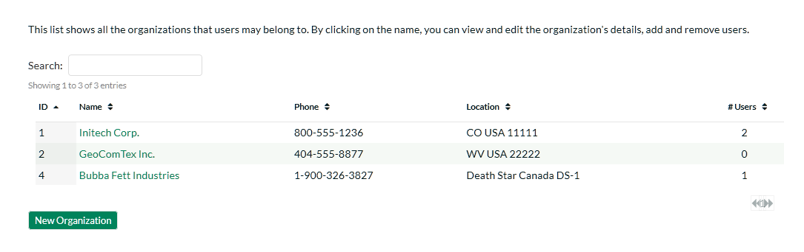

By clicking on the name, you will be taken to the edit page, where you can specify data about this organization:

* **Company Name**: The name of the company. Required.
* **Phone**: Phone number.
* **Address 1, Address 2, City, State, Zip/Postal Code**: Mailing address.
* **Country**: The country. Required.
* **Description**: Displayed when managers/supervisors of the company edit their own profile.
* **Internal Notes**: Displayed for application administrators only.
* **Users**: List of users that are members of this organization.

Users can be added by clicking the add user button (), and selecting the users to be added. There are three roles a user can be inside an organization:

* **Member**: These customers can see other organization tickets and view organization details and members, but can not change them. They can create new tickets.
* **Supervisor**: These customers can edit all organization tickets including changing the opener of the ticket. They can view organization details and members.
* **Manager**: These customers can do everything the Supervisor can, as well as invite new users to the organization.

When users are added to an organization by the application administrator, they are automatically added as a ‘Member’. When a Manager adds a user to an organization, they must know the user’s email address, and the next time the user logs on they are presented with a prompt to join the organization, which they may accept or deny.

### 3.2.5. User Roles

You can create and modify user roles here. By default, the standard roles are:

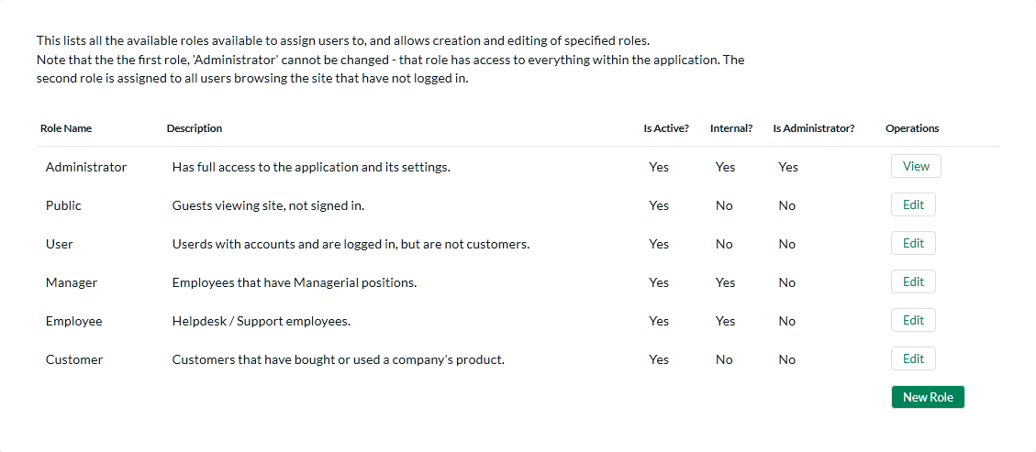

The following roles exist in the system and can be used when assigned permissions to users:

* **Administrator** – The most powerful role in the system, they can view, create, modify and delete all artifacts in the system (articles, tickets, forums, threads, replies) as well as access the administration section where they can change all application-wide settings.
* **Public** – All users that are viewing the site that are not logged in.
* **Manager** – This role can view, create, modify and delete all artifacts in the system (articles, tickets, forums, threads, replies). This role cannot access the Administration section
* **Employee** – This role can view everything in the non-administration section of the application. This role can view, modify and create tickets, articles, threads and replies. It cannot delete items in the system.
* **Customer** – This role can view all articles and forums, can submit new threads, reply to existing threads, can log help desk tickets and view/modify tickets that they opened only.
* **User** – This role can view all articles and forums, can submit new threads, and reply to existing threads. This role does not have any access to the help desk ticketing section of the application.

When editing a role, you can give it certain permissions:

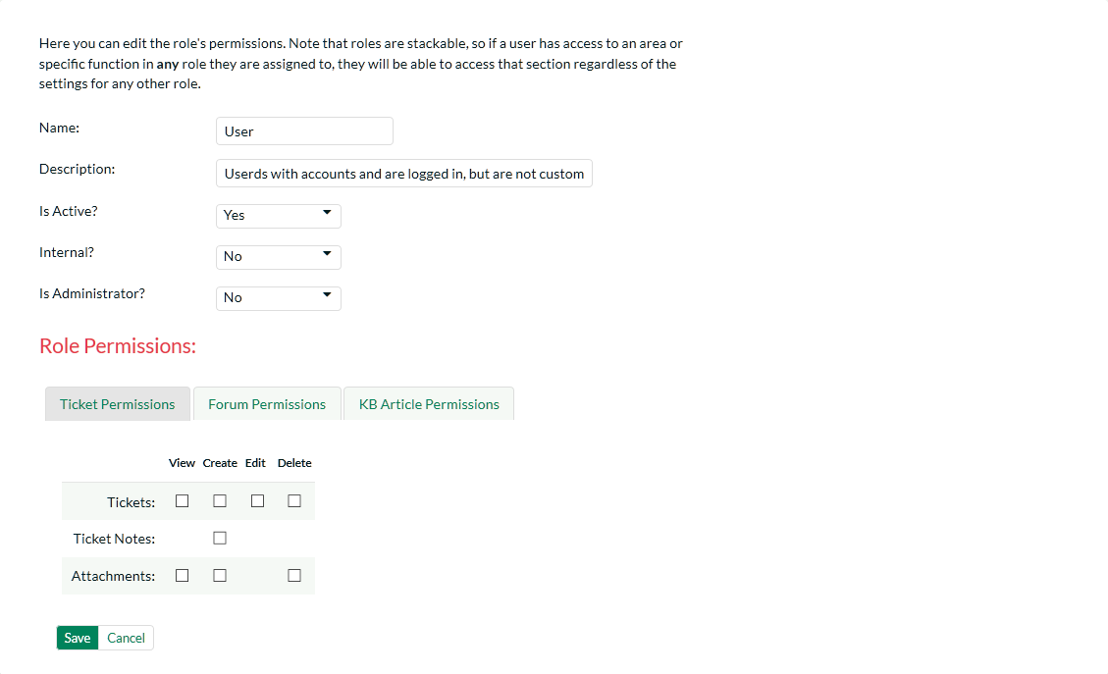

The name of the role is used in the Role selection box, when editing a user.

Description is just used for administration purposes, and is not displayed anywhere to end-users.

Internal is a flag – if set to true, Internal users are considered employees of the company, and have some additional permissions granted to them. If this option is set to ‘No’, then they are considered an External Customer (End-User).

The tabs then let you specify what the role can do in each section of the application.

**Important Note**: Roles can be stacked – that is to say, Users can be assigned to more than one role at a time. Roles will be ANDed together. So if ANY role is marked ‘Internal’, then the user will be considered an employee. Likewise, if ANY role allows a user to create a ticket, then no matter what the other roles say, the user will be able to create a ticket. It is also important to note that is the section is disable entirely, setting a permission here will not have any effect.

### 3.2.6. View Active Sessions

Often an administrator of the system will want to know how many users are currently logged into the system, especially on installations licensed by concurrent-user. Clicking on the ‘Active User Sessions’ administration option will display a list of all the users who currently have active sessions in the system:

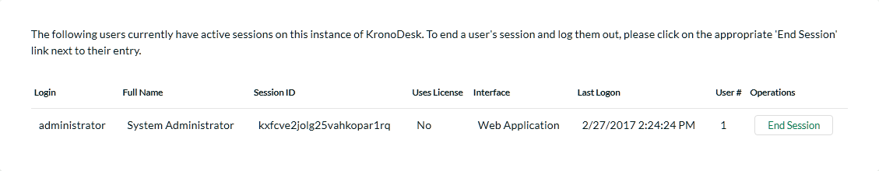

Each user is displayed along with their user ID, whether they’re connected through the application or via a third-party add-on, the date they last logged-in, and whether they are being counted as concurrent-user from a licensing perspective. With a concurrent-user license, KronoDesk allows an unlimited number of general user sessions, but only a certain number of customer service agent user sessions.

The administrator is able to forcibly end a user’s session using the ‘End Session’ link to the right of their name. Clicking this link will result in that user being logged out when they try and perform an operation in the system. **Warning: You should make sure that the user is not actively using the system to prevent any unsaved data being lost**.

### 3.2.7. Manage Employee Groups

Employee Groups are used to manage tickets and service level agreements (SLAs) for organizations in the system. When groups are defined, tickets can then be assigned to a group of employees, as well as individual employees (as in previous versions of the application).

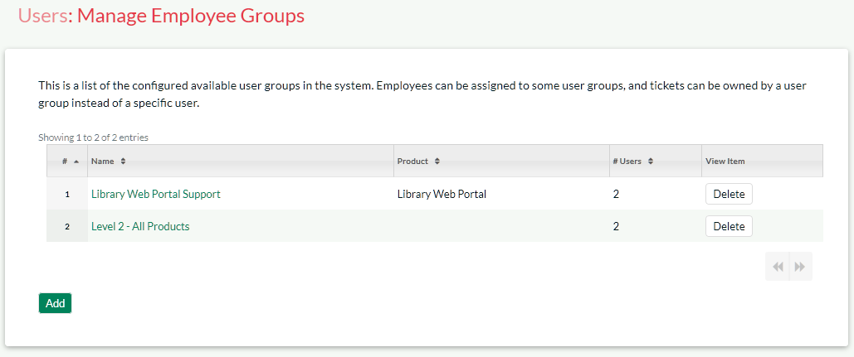

On the main Administration screen you can edit, delete, or create new groups. Deleting a group will remove all users from the group, and unassign all tickets (closed and open) that were assigned to that group.

Creating or editing a group will give you the following page:

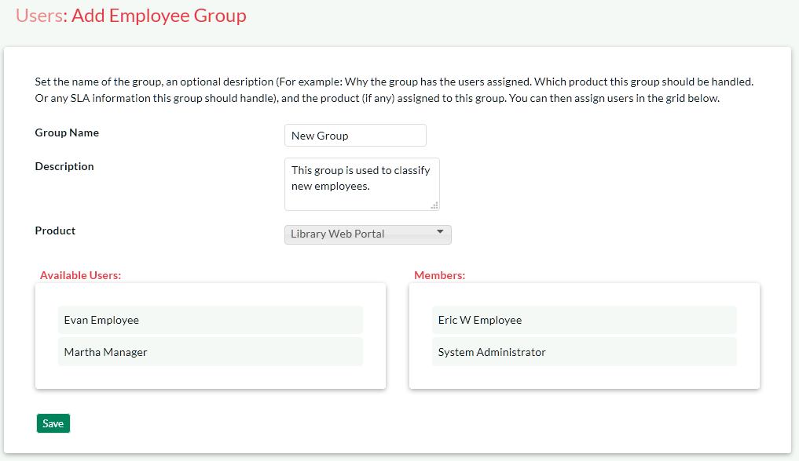

The fields available here are:

* **Group Name**: The display name of the group. This is displayed in the Assignee field for the Ticket.
* **Description**: This is just to describe the usage of this group. Not used anywhere but in Administration.
* **Product**: Assigning a group to a specific product. For future use with SLAs.
* **Members**: The members that are a part of this group.

Changes made on this page take effect immediately - after any users on the ticket pages refresh their display.

## 3.3. Forum Settings

This section contains all of the settings that affect the customer support forums part of the application.

### 3.3.1. Appearance

This page allows an administrator to customize the appearance of the customer support forums so that the standard text that is displayed matches the support policies of the organization. It also allows the administrator to customize some of the web page meta-data fields that can be used to optimize the support forums for Search Engine Optimization (SEO).

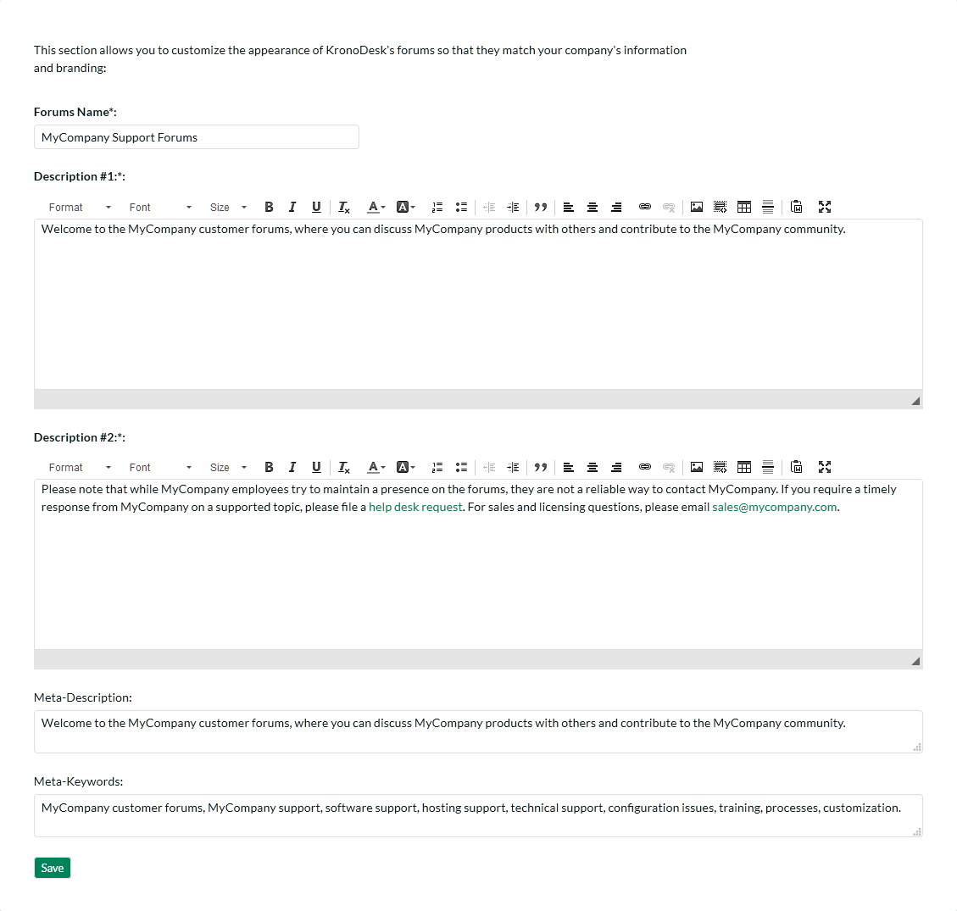

This page lets you specify the following values:

* **Forums Name** – You can change the title displayed for the online support forums to match your company’s name. For example you might want to rename the forums “Acme Inc. Support Forums”.
* **Description #1** – This rich text box contains the first paragraph of introductory text displayed on the support forums home page.
* **Description #2** – This rich text box contains the second paragraph of introductory text displayed on the support forums home page.
* **Meta-Description** – This plain text box contains the HTML Meta-Description field that is not displayed in the web browser, but is often used by search engines to rank the content. You may want to modify this to ensure that your support forums are ranked highly on Internet search engines. It should contain a brief description of your company, its products, and the support forums
* **Meta-Keywords** – This plain text box contains the HTML Meta-Keywords field that is not displayed in the web browser, but is often used by search engines to rank the content. You may want to modify this to ensure that your support forums are ranked highly on Internet search engines. It should contain a comma-separated list of keywords related to your company and products/services.

### 3.3.2. Categories & Forums

This page lets administrators manage the different categories and forums used in the KronoDesk customer support forums. The customer forums are divided up into categories and each category has a set of forums. Typically the forum categories are associated with a particular product or service, although there may be some general categories that are product agnostic.

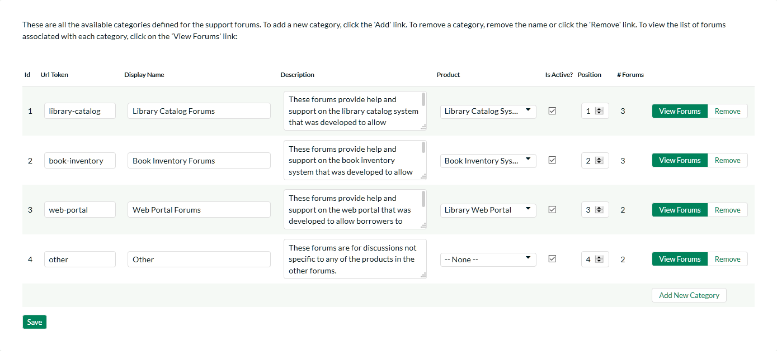

When you first open this page, the system will list all the forum categories already in the system. You can use this page to perform the following operations:

* **Modify an Existing Category** – to do this, you simply need to update the URL-Token, Display Name, Description, Product, Active flag and Position value for the category and click [Save].
  + **URL Token** – This is the URL segment that will be used to create the hyperlink to access this forum category (e.g. <http://myserver/KronoDesk/Forum/url-token.aspx>). Url Tokens have to be unique and can only contain alphanumeric characters and hyphens.
  + **Display Name** – This is the name of the category that will be displayed in the category details page.
  + **Description** – This is the long description of the category that will be displayed in the category details page.
  + **Product** – If the category is related to a specific product, you should select the product.
  + **Active** – This should be checked if you want the category to be visible within the application. Old categories that are no longer in use should be made inactive.
  + **Position** – This should be used to specify the order of the categories.
* **Create a New Category** – to this, you simply need to click on the “Add New Category” hyperlink in the bottom row and then enter the new category information and click [Save].
* **Delete an Existing Category** – to do this, simply click on the “Remove” hyperlink next to the category. You will be asked to confirm the deletion, after which the category will be deleted from the system. *Note: If you delete a forum category, the system will delete all the forums, threads and message contained within that category.*

To view the list of forums associated with a particular category, you should click on the “View Forums” link that will display the appropriate list of forums:

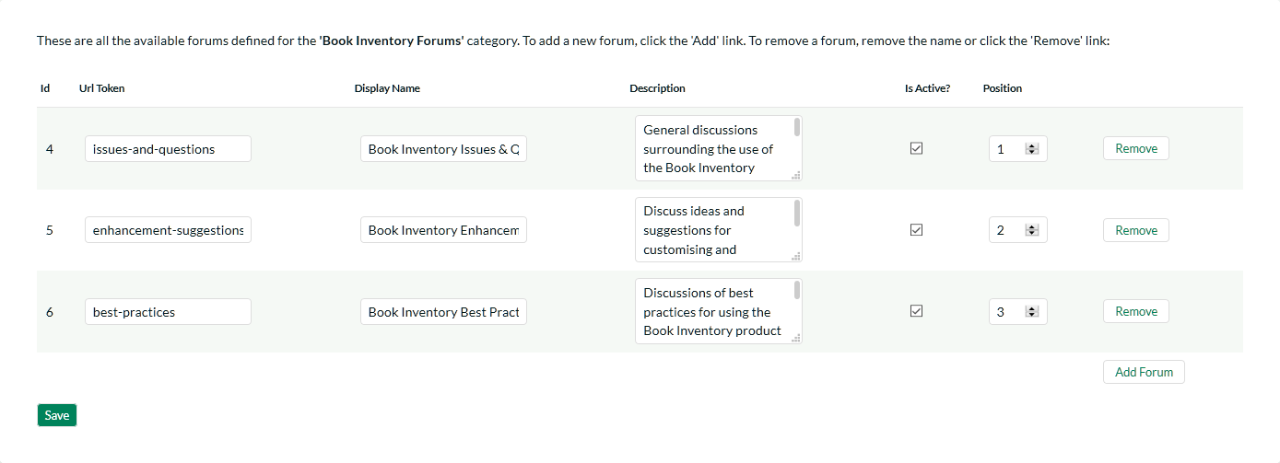

You can use this page to manage the various forums in the category:

* **Modify an Existing Forum** – to do this, you simply need to update the URL-Token, Display Name, Description, Active flag and Position value for the forum and click [Save].
  + **URL Token** – This is the URL segment that will be used to create the hyperlink to access this forum (e.g. <http://myserver/KronoDesk/Forum/category/url-token.aspx>). Url Tokens have to be unique for the specific category and can only contain alphanumeric characters and hyphens.
  + **Display Name** – This is the name of the forum.
  + **Description** – This is the long description of the forum that will be displayed in the forum details page.
  + **Active** – This should be checked if you want the forum to be visible within the application. Old forum that are no longer in use should be made inactive.
  + **Position** – This should be used to specify the order of the forums in the category.
* **Create a New Forum** – to this, you simply need to click on the “Add Forum” hyperlink in the bottom row and then enter the new forum information and click [Save].
* **Delete an Existing Forum** – to do this, simply click on the “Remove” hyperlink next to the forum. You will be asked to confirm the deletion, after which the forum will be deleted from the system. *Note: If you delete a forum, the system will delete all the threads and message contained within that forum.*

## 3.4. Knowledge Base Settings

This section contains all of the settings that affect the online knowledge base part of the application.

### 3.4.1. Article Categories

This page lets administrators manage the different article categories used in the KronoDesk online knowledge base. Each article in the knowledge base is assigned to one or more article category which is used to make finding information easier. Typically the article categories are associated with a particular product or service, although there may be some general categories that are product agnostic.

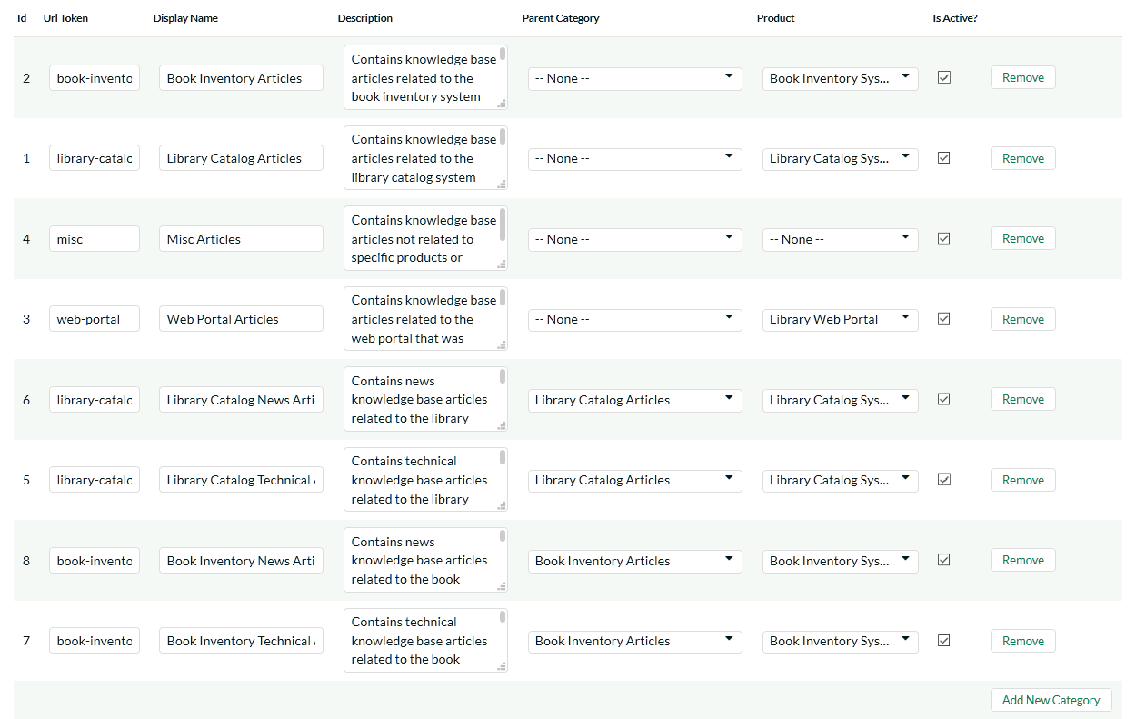

When you first open this page, the system will list all the article categories already in the system. You can use this page to perform the following operations:

* **Modify an Existing Category** – to do this, you simply need to update the URL-Token, Display Name, Description, Parent Category, Product and Active flag value for the category and click [Save].
  + **URL Token** – This is the URL segment that will be used to create the hyperlink to access this forum category (e.g. <http://myserver/KronoDesk/KnowledgeBase/url-token/List.aspx>). Url Tokens have to be unique and can only contain alphanumeric characters and hyphens.
  + **Display Name** – This is the name of the category that will be displayed in the category details page.
  + **Description** – This is the long description of the category that will be displayed in the category details page.
  + **Parent Category** – If this is a top-level category, you should leave it set to “None”, otherwise you need to set this to the name of the existing article category that the category will be listed under.
  + **Product** – If the category is related to a specific product, you should select the product.
  + **Active** – This should be checked if you want the category to be visible within the application. Old categories that are no longer in use should be made inactive.
* **Create a New Category** – to this, you simply need to click on the “Add New Category” hyperlink in the bottom row and then enter the new category information and click [Save].
* **Delete an Existing Category** – to do this, simply click on the “Remove” hyperlink next to the category. You will be asked to confirm the deletion, after which the category will be deleted from the system. *Note: If you delete an article category, the system will delete all the child categories and articles contained within that category.*

## 3.5. Help Desk Settings

This section contains all of the settings that affect the help desk ticketing part of the application.

### 3.5.1. Custom Fields

Tickets in the Help Desk system can have up to 20 custom fields. There are different types of custom fields allowed:

* **Text**: Normal or Rich-Text field.
* **Integer**: Whole-Number entry.
* **Decimal**: Fractional number entry (currency, etc.)
* **Boolean**: Simple yes/no (on/off) checkbox.
* **Date**: Date selector.
* **List**: Custom List selector.
* **Multi-List**: Custom List selector that allows multiple values.
* **User**: List of assignable users.

Each custom field can have optional settings applied to it. Optional settings are as follows. (Note that not all settings are available for all field types.)

* **Default**: The default value when a new ticket is opened up.
* **Precision**: How many decimal places is allowed (or the value is rounded to).
* **Minimum Value**: The minimum value allowed.
* **Maximum Value**: The maximum value allowed.
* **Minimum Length**: The minimum length of the data required in the field.
* **Maximum Length**: The maximum length of the data allowed in the field.
* **Rich Text**: Whether or not the text field allows HTML or not.
* **Custom List**: The defined Custom List for the field that users can select from.

Going to the main page, you will see a list of custom field defined for Tickets:

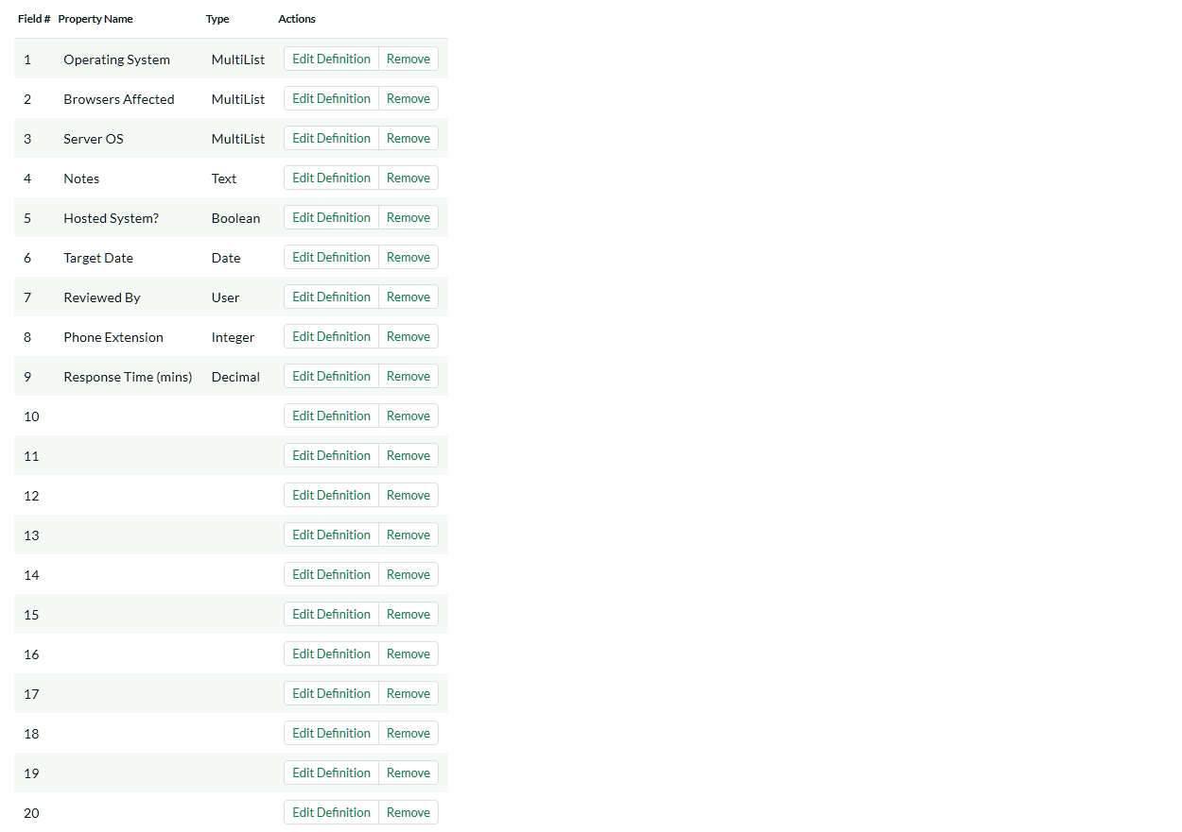

To edit a definition, click the Edit Definition link on a field, and you will get a popup:

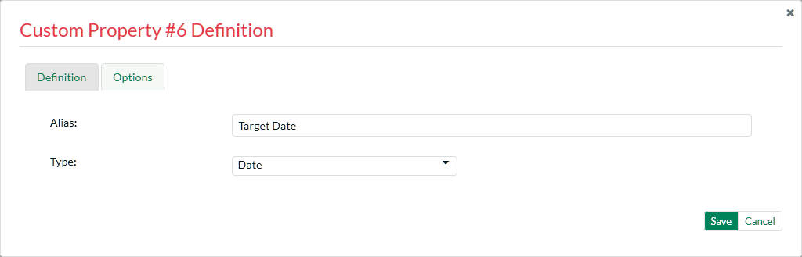

The fields visible will vary depending on the type of custom field you have selected, but every custom field will need to have an Alias and a Type. The Alias is what is shown to the user when viewing or editing the ticket. The type is the type of data the ticket allows.

Under the Options tab will be available options that can be set for the custom field.

When finished, click the ‘Save’ button and you will be returned to the Custom Field list.

***Important Note:*** When changing a custom field’s type or removing a field, the data is not actually removed from the ticket. Therefore, if you change a custom field of a date into a text, the field will display the old date value until it is changed by the user.

### 3.5.2. Ticket Statuses

Ticket statuses can be edited using the grid that displays all defined statuses.

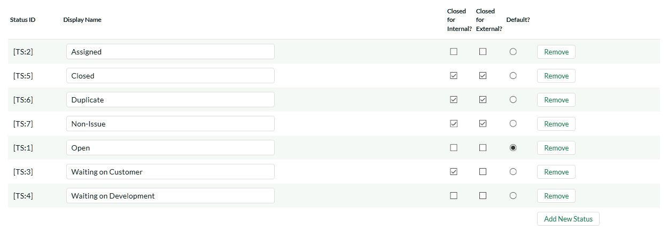

All statuses must have a display name, which is viewed by the user editing or viewing the ticket. The other fields are:

* **Closed for Internal?** - Whether this status is considered as inactive for internal users (employees, support agents, etc.). For example the sample status ‘Waiting on Customer’ would be considered ‘Closed for Internal’ because customer support agents do not want to see such tickets in their list when it’s waiting for a customer to respond.
* **Closed for External** - Whether this status is considered as inactive for external users (customers, etc.). For example the sample status ‘Waiting on Customer’ would be considered ‘Open for External’ because end users / customers would definitely want to see such tickets in their list since the support agent is waiting for their response.
* **Default?** - The status selected as the default is the status that new tickets are opened as.

To add a new Status, click the Add New Status link – a new row will be inserted into the table where you can save the new status.

To remove a status, click the Remove link. Any tickets with a status that has been removed will stay that status, until the next time a user edits the ticket.

In addition to this screen that lets you edit the ticket statuses, if you click on the “Advanced” option in the left hand navigation, it will bring up the screen that lets you specify some additional status change rules:

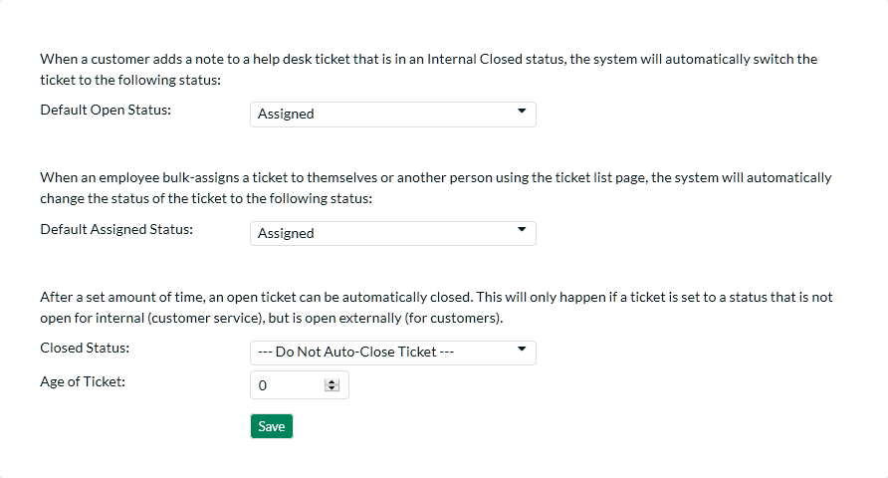

There are several options you can configure:

* **The Default Open Status** – this allows you to specify the status that a ticket will be automatically switched to when a new note is added by the person who originally opened the ticket. This is useful when a customer accesses one of their existing tickets that’s in a closed status but forgets to change the status back to an open status. This ensures that such tickets do not get forgotten about.
* **The Default Assigned Status** – this allows you to specify the status that a ticket will be automatically switched to when you use the bulk assign tools on the main Help Desk page. For example five new tickets arrive and you select them and choose the option to “Assign Tickets to Me”. When they are assigned in this way, the system will automatically change their status to the default assigned status option (if specified).
* **Closed Status** – After a set amount of time, an open ticket can be automatically closed. This will only happen if a ticket is set to a status that is not open for internal (customer service), but is open externally (for customers). The dropdown list contains the status that the ticket will be switched to.
  + **Age of Ticket** - Allowable values: 7-365. After the ticket is this number of days old, the status will be automatically closed.

### 3.5.3. Ticket Types

The Ticket Type page defines values allowed for the standard Type field for tickets. Types must have a unique display name, which is what the user sees when they view or edit a type.

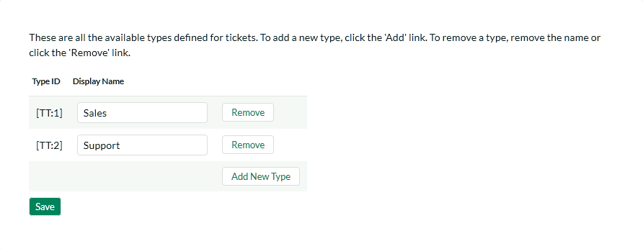

To add a new type, click the Add New Type link, and fill out the new empty row.

To remove a type, click the Remove button to the right of the defined type. Note that any tickets assigned to a type that is removed will retain their type, until the next time a user tries to edit the ticket.

### 3.5.4. Ticket Priorities

The Ticket Priorities page defines values allowed for the standard Priority field. Like types, priorities must have a unique name.

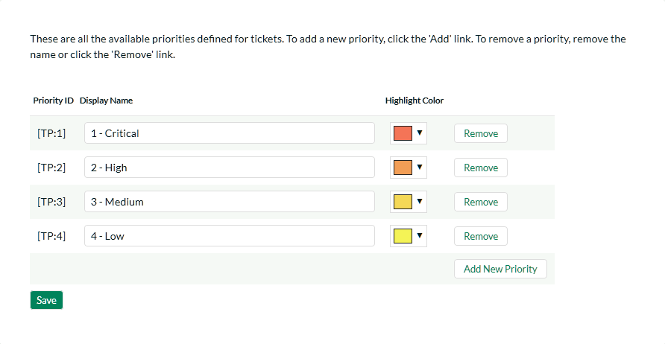

To add a new priority, click the Add New Priority link, and fill out the new empty row.

To remove a priority, click the Remove button to the right of the priority. Note that any tickets assigned to a priority that is removed will retain their value, until the next time a user tries to edit the ticket. Colors assigned to the priority will appear in the Ticket List page in the Priority column.

### 3.5.5. Ticket Resolutions

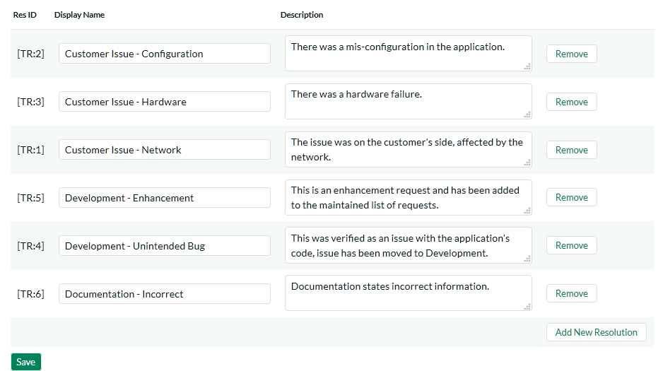

The Ticket Resolutions page defines values allowed for the standard Resolution field. Like types and priorities, resolutions must have a unique name. The description is used internally, and should just contain a short summary of the meaning of the resolution.

To add a new resolution, click the Add New Resolution link, and fill out the new empty row.

To remove a resolution, click the Remove button to the right of the resolution. Note that any tickets assigned to a resolution that is removed will retain their value, until the next time a user tries to edit the ticket.

### 3.5.6. Spira Integration

When customer support agents work on tickets received from customers, they may find that the issue is actually a product defect rather than a customer support matter. In which case, they can take advantage of the built-in integration with [SpiraTeam](http://inflectra.com/SpiraTeam)® - Inflectra’s award winning Application Lifecycle Management (ALM) solution that has a powerful product incident management system.

KronoDesk® has the ability to connect to an instance of SpiraTeam® and add new product incidents into the system that are linked to the originating KronoDesk Ticket. That allows customer service agents to monitor the status of the associated product incidents and inform customers when the appropriate patches or fixes are available to correct the problem.

This screen allows the administrator to setup the connection between SpiraTeam and KronoDesk.

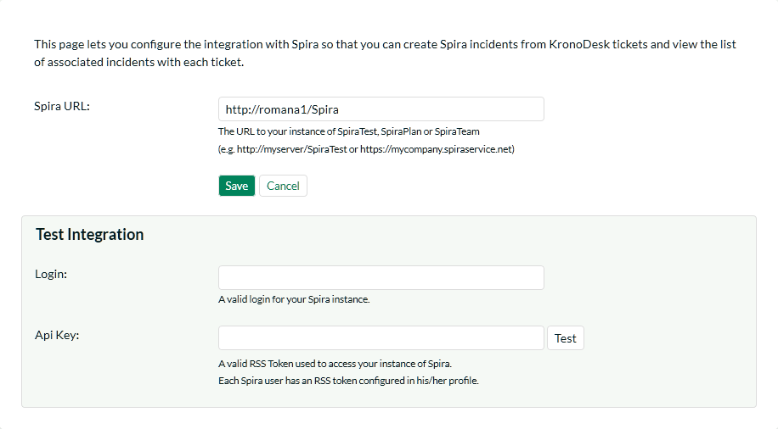

You should enter the URL that your users use to access their instance of SpiraTest, SpiraPlan or SpiraTeam (including the HTTP or HTTPS prefix) together with the SpiraTeam login and RSS Token for a valid SpiraTeam user. The login and associated RSS Token is used to verify the connection.

Once you have entered the information, you should click the [Test] button to verify that the URL is accessible. If there are connectivity issues, and error will be displayed, otherwise a green confirmation message will appear. Once the connection information has been successfully verified, you need to click the [Save] button to save the connection settings in the system.

### 3.5.7. Ticket Article Templates:

Templates can be created for quick replies to support tickets. This allows for support agents to quickly respond to support tickets referencing a related KB Article.

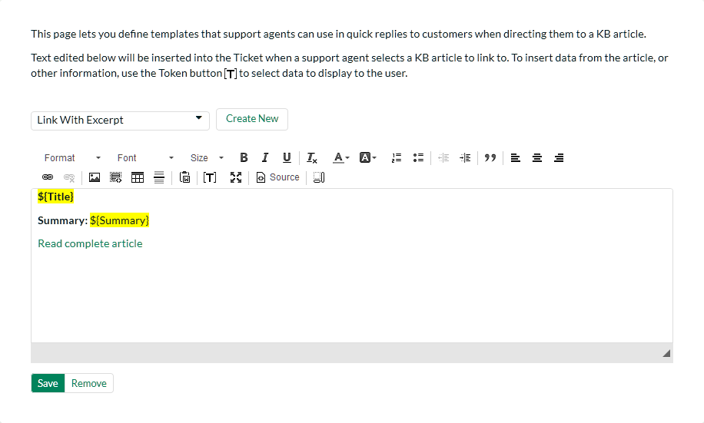

You can edit or create a new template, and to reference the selected KB Article, you can use a set of templates, available in the (**[T]**) toolbar button. The support agent can then select one of these templates on the Ticket Details page, along with a KB article to insert into the agent’s reply.

## 3.6. Workflows

This section displays a list of the defined ticket workflows in the system. A workflow is a predefined sequence of ticket statuses linked together by “workflow transitions” to enable a newly created ticket to be reviewed, prioritized, assigned, resolved and closed, as well as to handle exception cases such as the case of a duplicate or non-reproducible ticket. The initial workflow list screen when you first use the system is illustrated below:

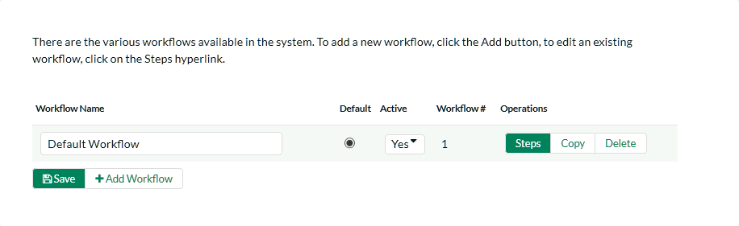

To modify the name, default status, and/or active flags, simply change the values in the appropriate text-box, radio-button or drop-down list and click the [Save] button. To add a new workflow, simply click the [Add Workflow] button and a new workflow will be created with the standard KronoDesk steps and transitions.

You can have as many workflows as you like in a project, but only one can be marked as the default. Each KronoDesk product is assigned to a workflow; this allows you to have support tickets for different products follow different paths from creation to closure. However when a new product is created, it will be initially associated with the default workflow. The steps and transitions that make up the default workflow are illustrated in the diagram below:

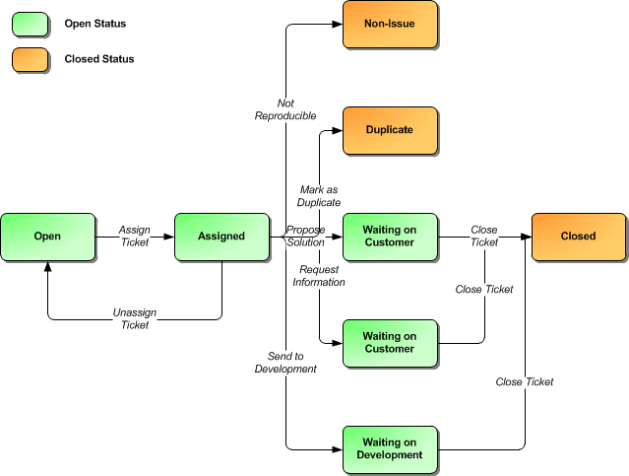

Note: You can only assign an active workflow to a KronoDesk product, and similarly you cannot make a workflow inactive that is currently linked to at least one product. This is important as all products need to be linked to an active workflow at all times.

### 3.6.1. Edit Workflow Details

Clicking on the <Steps> button of an inactive workflow brings up the following screen that lists all the workflow steps and workflow transitions that comprise the workflow:

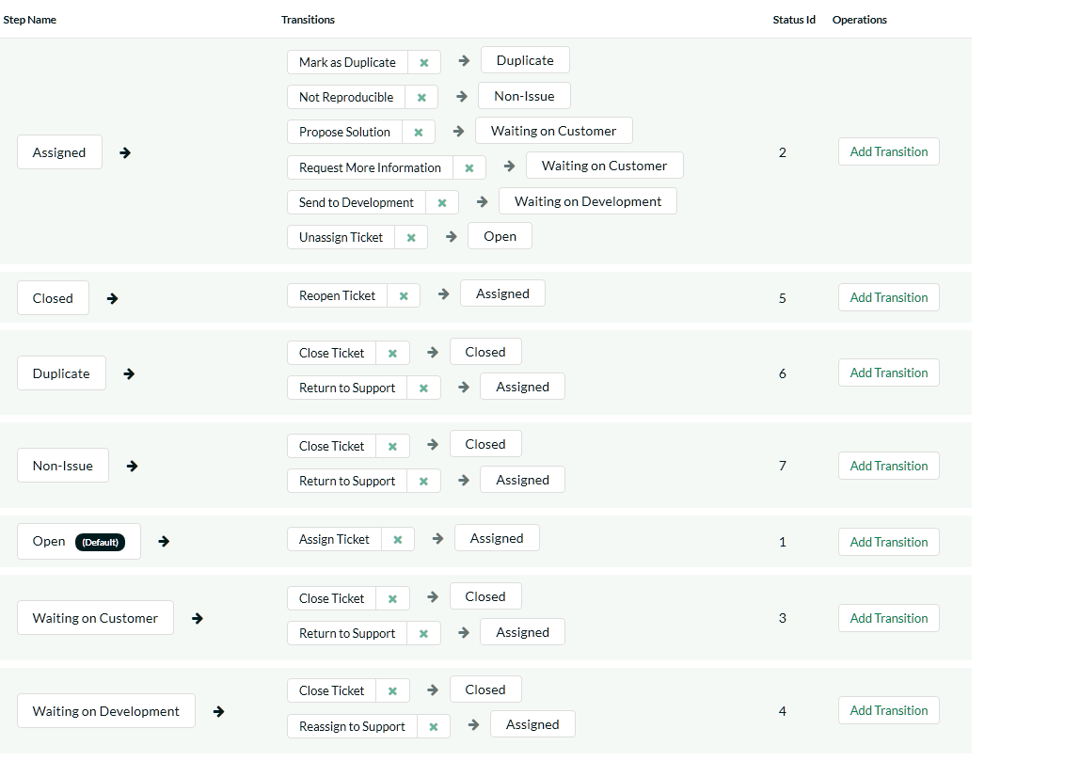

This page lists in the left-most column all the various incident statuses defined in the system. The next column lists all the possible transitions that can occur *from that status*. In addition, with each transition is listed the name of the resulting *destination status* that the transition leads to. E.g. from the assigned status, depending on your role (see later) you can move the ticket to either Open, Waiting On Customer, Waiting on Development, Duplicate and Non-Issue depending on which transition the user takes.

Clicking on the name of a step or transition takes you to the appropriate details page (see below) where you can set the properties of the step or transition respectively. To delete an existing transition, simply click the <Delete> button after the transition name, and to add a new transition, click the <Add Transition> button in the Operations column.

### 3.6.2. Edit Workflow Transition

When you click on the transition name link from the previous screen, you are taken to the workflow transition details screen:

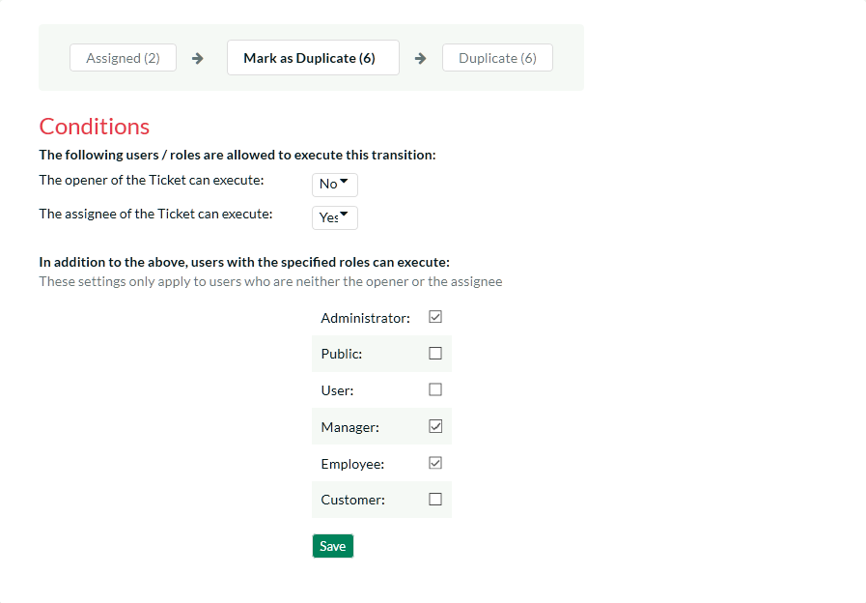

The top part of the screen is the “workflow browser” which illustrates how the transition relates to the workflow as a whole. It displays the current transition in the middle, with the originating and destination steps listed to either side. Clicking on either ticket status name will take you to the appropriate workflow step details page. This allows you to click through the whole workflow from start to finish without having to return to the workflow details page.

Each transition has a series of conditions which need to be satisfied for a user to actually execute the transition (i.e. move the ticket from the originating status to the destination status). The conditions allow you to set three types of user role:

* The opener of the ticket can be allowed to execute the transition when the transition occurs. For example, when a ticket is marked as Waiting on Customer, the opener should be the only one who’s allowed to move it to Closed.
* The assignee of the ticket can be allowed to execute the transition when the transition occurs. For example, when a ticket is marked as Assigned, the assigned agent should be the only one who’s allowed to move it to Waiting on Customer.
* A user with a specified role can be allowed to execute the transition, when the transition occurs regardless of whether they are the opener or assignee. For example a user with role “Manager” might want the power to close all tickets regardless of assignee status.
* Whether a Digital Signature is required for this transition or not. If set to Yes, then when the transition is performed, the user must re-enter their username, password, and a note (if applicable) on the transition. This signature is recorded in the History for future reporting.

You can set any of these conditions by changing the drop-down list and/or check-boxes and clicking the appropriate <Save> button.

### 3.6.3. Edit Workflow Step

When you click on the ticket status name link from either of the previous screens, you are taken to the workflow step details screen:

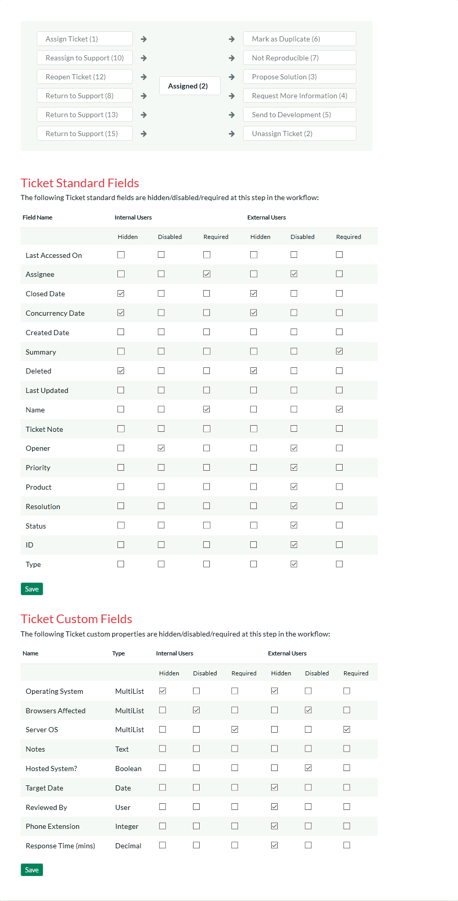

The top part of the screen is the “workflow browser” which illustrates how the step relates to the workflow as a whole. It displays the current ticket status in the middle, with the possible originating and destination transitions listed to either side. Clicking on either workflow transition name will take you to the appropriate workflow transition details page. This allows you to click through the whole workflow from start to finish without having to return to the workflow details page.

This page allows you to define the behavior of the various ticket fields (i.e. those that are a standard part of KronoDesk such as Priority) and ticket custom properties for this particular step in the workflow. You can set each of the fields/custom properties as being hidden, disabled, and/or required for each step in the workflow, and for Internal (support) users, and External (end-user) users. Note that you cannot set a field/property as being required and disabled since this would prevent a user from ever updating the ticket. For example, when a ticket is in the Open status, you might make the assignee field inactive (since the opener shouldn’t need to know who will ultimately work on it), when it gets to the Assigned status, you might make the field enabled and required. This allows you to tailor the information gathered to the appropriate place in the workflow.

To actually make these changes, all you need to do is select the appropriate checkboxes in the list of fields and custom properties and click the corresponding <Save> button.

## 3.7. Event Notifications

This section allows you to customize the email notifications that are sent out by KronoDesk when specific help desk events occur in the system. When you first click on the section link, the system will display a list of any notification events that already exist:

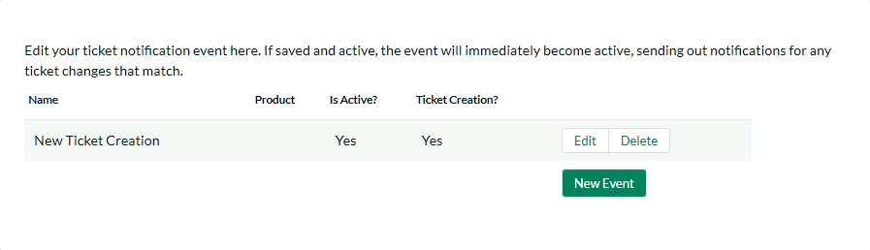

To create a new event, click on the ‘Create New Event’ hyperlink. That will display the page that lets you add or edit help desk notification events:

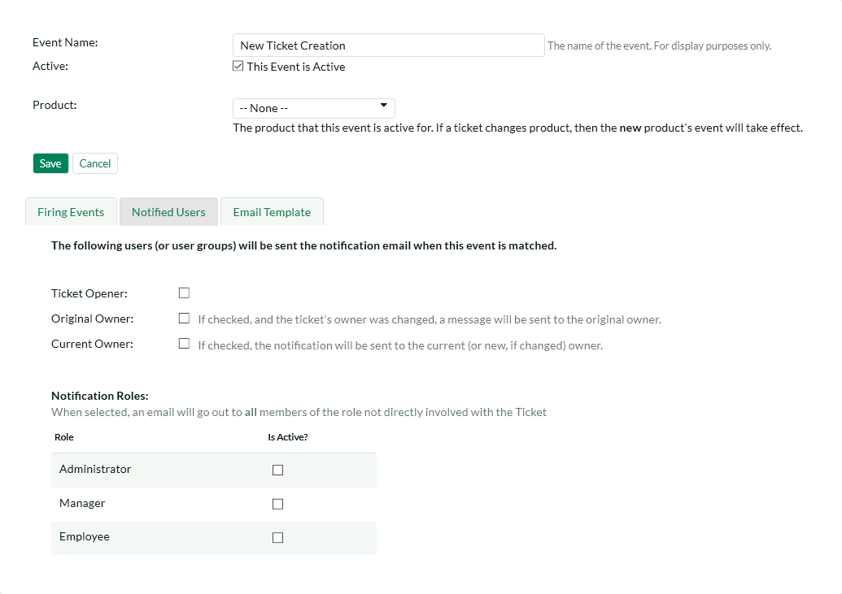

For each event you need to specify the name of the event, this is not used in the email and is just used to help you identify what the purpose and scope of the notification is (e.g. “Send emails to customers when a new ticket is logged”). In addition, you should specify if the event is active or not and what product that the event is active for. That way you can have different events occur for different products.

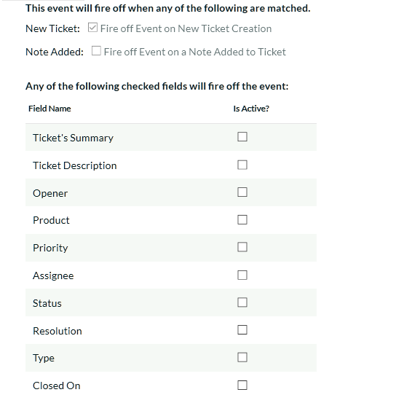

The **Firing Events** section of the notification lets you specify which events will trigger the notification being sent. There are three types of event that can occur:

* **New Ticket** – When a new help desk ticket is created (by a customer) this event is triggered. If you want the notification to be sent when a new ticket is created, you should check this option.
* **Note Added** - When a note is added by a user to an existing help desk ticket, this event is triggered. If you want the notification to be sent when a note is added, you should check this option.
* **Field Changed** – When one of the checked fields is changed by a user, this event is triggered. Check any of the fields that you want to trigger the notification in question.

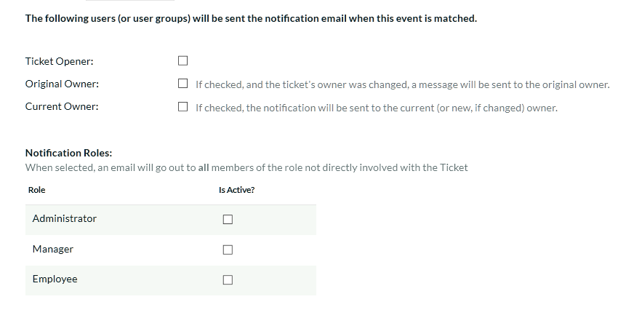

The **Notified Users** section of the notification lets you specify which users will receive the email notifications when the event gets triggered. There are four types of user that can be specified:

* **Ticket Opener** – This option will result in the notification being sent to the person that originally opened the ticket.
* **Original Owner** – This option will result in the notification being sent to the person that the ticket was originally assigned to.
* **Current Owner** – This option will result in the notification being sent to the person that the ticket is now assigned to.
* **Notification Roles** – These options allows you to specify which other roles in the system will get notified about changes to the ticket. Only Internal roles can be selected.

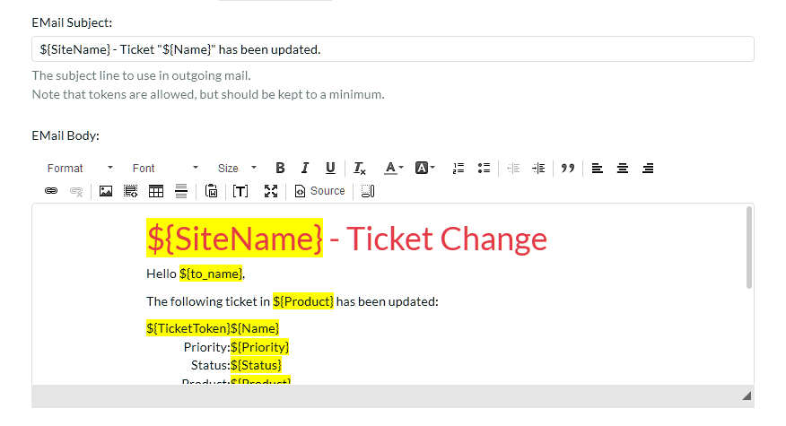

The **Email Template** section lets to specify the template used for the email notification in question. The template consists of the email subject line and body.

Similar to the settings in System -> Email, tokens can insert relevant data to the ticket into the email. Using the token button (**[T]**) in the toolbar.

Tokens will be replaced when the email is sent out with information relevant to the ticket or system configuration at that time.

# 4. Appendices

## 4.1. Appendix A – Troubleshooting

If you receive the dreaded “IIS 500 Internal Error” or the “Server Application Not Available” webpage when you try and access KronoDesk® for the first time, there can be a myriad of causes. However a good first place to look for the cause is inside the Windows Event Viewer, which stores all errors raised in the system.

To open the Event Viewer, click Start > Settings > Control Panel > Administrative Tools > Event Viewer. This will open up the event viewer:

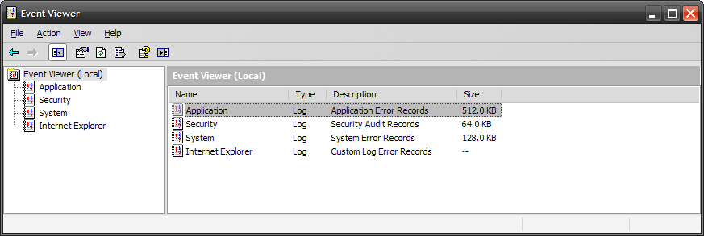

Click on the Application and System folders in turn and look for errors raised by “MSSQLSERVER”, “KronoDesk”, “DCOM”, “ASPNET” or “IIS”. Click on the error message, and copy the text of the message into a text editor (e.g. Notepad).

Before contacting Inflectra® customer support with the specific error message, here are a couple of common causes for the above errors together with the appropriate resolutions:

* **The ASP.NET process account has been disabled**  
  Go to Start > Control Panel > Administrative Tools > Computer Management and launch the Windows computer management console. Expand Local Users and Groups > Users and then double-click on the 'ASPNET' account. Make sure that the ASPNET user is not disabled.  
  If you are using Windows 2003 or 2008 Server the ASPNET user is set per-application pool and typically is set to the built-in NETWORKSERVICE account, so this won’t apply.
* **The ASP.NET process account does not have sufficient permissions**  
  Right-click on the C:\WINDOWS\Microsoft.NET\Framework\v4.0.30319 folder (and any other versions of .NET that are listed) and make sure that the ASPNET, NETWORKSERVICE and LOCALSERVICE accounts are all listed with Full Control. If that doesn’t fit the issue and you are using Windows 2003 or 2008 Server, open up the IIS manager and right-click on the Application Pool that KronoDesk® is running under and make sure that the identity listed has Full Control permissions on the same folders.
* **The Windows Event Log is full**  
  Open up the Application and System event logs, right-click on the log name and choose Properties. Make sure that both are set to “overwrite events as needed”. If they are not set to overwrite as needed, change the setting then manually clear both logs.

If the resolutions above were not able to resolve the issue, please send an email to [support@inflectra.com](mailto:support@inflectra.com) and include the error message from both the web page and the Windows Event Logs.

### 4.1.1. Missing MSDTC Issue

There is one common error that has been found with installations where Microsoft SQL Server was installed *after* IIS was installed. This typically affects only Windows XP Professional, but could occur in other situations. What happens is that the SQL Server installation inadvertently removes the *Microsoft Distributed Transaction Coordinator* (MSDTC) service from the system during the installation.

To determine if this is indeed the cause of the observed error, you need to click on Start > Settings > Control Panel > Administrative Tools > Component Services:

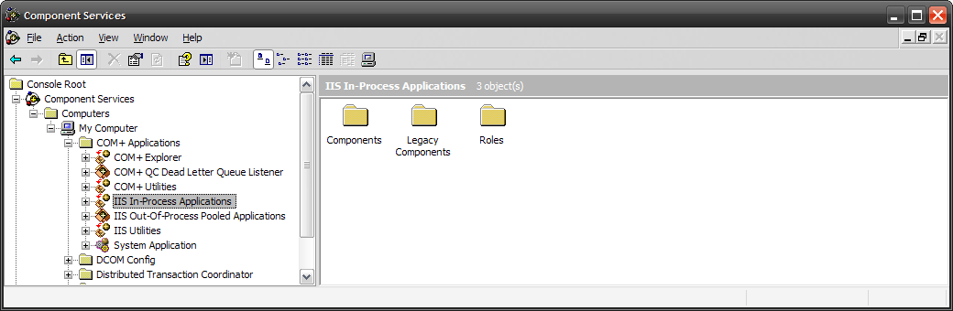

Once the window has opened, expand the folders marked “Component Services”, “Computers”, “My Computer” and “COM+ Applications” in turn. If the window opens correctly and displays the information illustrated above, then your IIS 500 error is being caused by something else.

However if you receive an error message that indicates an inability to connect with the “Distributed Transaction Coordinator”, then you have to fix the MSDTC service to enable IIS and ASP.NET to operate properly.

To fix the issue, you need to make changes to the Windows System Registry (hereafter referred to as “the registry”). This is a process that should **not** be attempted by novice users, since any incorrect changes can complete wreck the Windows installation, requiring a complete reinstallation of the operating system.

To open the registry, click Start > Run, and type “Regedit.exe” into the dialog box, and the registry will open:

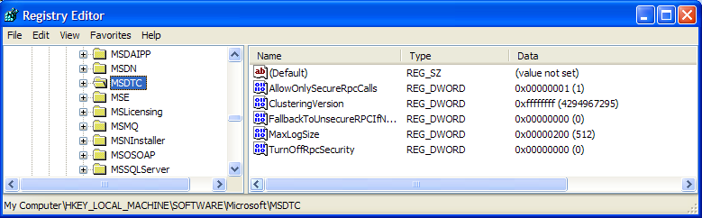

Expand the folders marked “My Computer”, “HKEY_LOCAL_MACHINE”, “SOFTWARE” and “Microsoft” in turn and navigate to the folder marked “MSDTC”. Click the <Delete> button on your keyboard, and click <OK> on the confirmation box. Now close the registry editor.

Now you need to click on Start >Settings > Control Panel > Add or Remove Programs and click on the tab marked “Add/Remove Windows Components”:

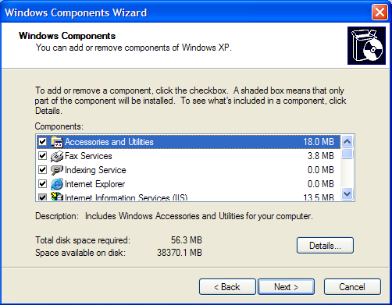

Don’t change any of the selected components, but instead simply click the <Next> button. The Windows installer will detect that the MSDTC is missing (due to the registry change you made) and will now reinstall it correctly. Once this has finished, reboot the system and you should now be able to access ASP and ASP.NET applications from within IIS.

### 4.1.2. Application Session Pooling Issues (Windows Vista, 7 or 2008)

This issue can affect Windows Vista, 7 or Server 2008 using IIS 7.0. Since the 6.0 release of IIS, there is the ability to separate the web-server into different “Application Pools”. Sometimes, web hosting companies will host multiple websites in the same application pool (which we do not recommend). When resources are maxed out for an application pool IIS 7 starts to recycle these sites causing application variables to be lost for those recycled sites. *By default, KronoDesk installs on these operating systems in its own application pool*.

***If you are experiencing application/session loss symptoms*** then we recommend asking your web hosting company to verify that your instance of KronoDesk is running in its own application pool with all recycling options disabled and the recycle worker process set to recycle only once during the day at a set time.

To make these changes yourself, you need to follow these steps:

Add new application pool for “KronoDesk” (if one does not already exist) and make sure it is set to use the .NET Framework v4.0 and the “Integrated Pipeline”:

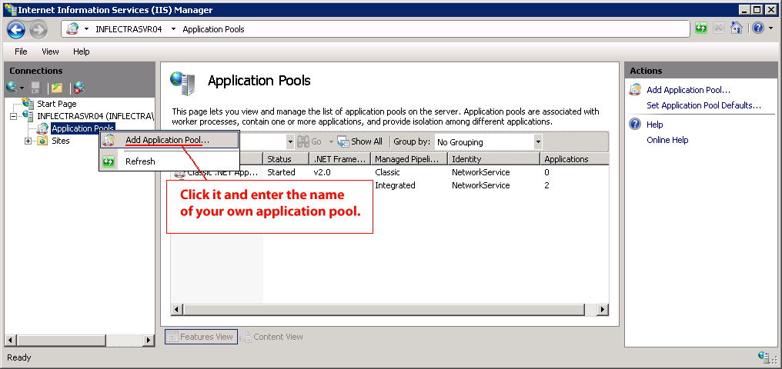

Next, choose your own application pool in the KronoDesk web site properties:

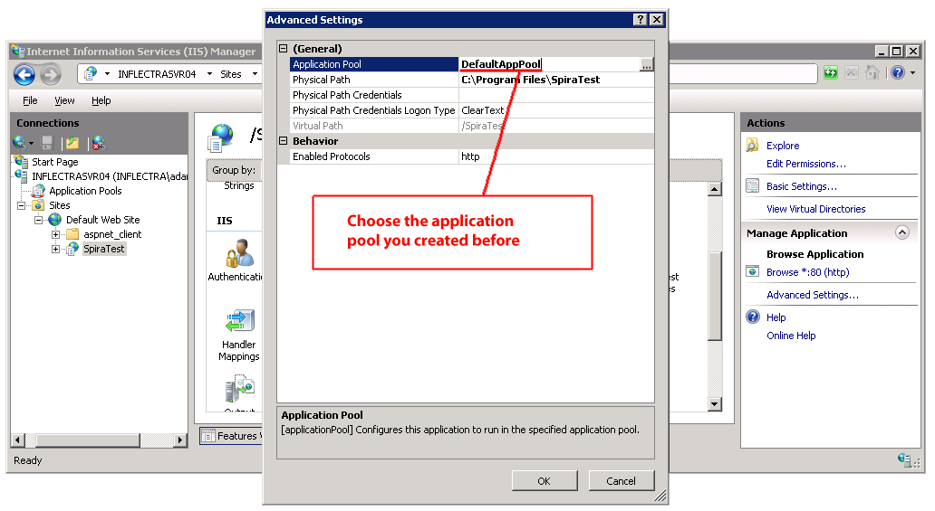

## 4.2. Appendix B – Using with SSL

This section outlines how you can install a Secure Sockets Layer (SSL) certificate onto IIS to allow users to access KronoDesk® via an encrypted protocol, so that usernames, passwords and sensitive project data cannot be “sniffed” across the network. This is especially important if your web-server is being accessed across the Internet.

This section assumes that you already have a Certificate Authority (CA) available to generate an SSL certificate for you. This can either be a third-party provider (e.g. Verisign) or a tool used to generate “self certificates” that can be used internally to your organization. For more information on the differences between these two options, please read the following documents:

<http://www.microsoft.com/technet/prodtechnol/WindowsServer2003/Library/IIS/8d3bb71a-0a7f-443f-8084-908d0dab9caa.mspx?mfr=true> (installing self or third-party certificate on Windows Server 2003)

<http://www.somacon.com/p42.php> (installing self-certificate on Windows XP)

Once you have decided how you will generate the certificate, you next need to generate the request for the certificate from your web server. First, click Start > Settings > Control Panel > Administrative Tools > Internet Information Services to bring up the IIS management console:

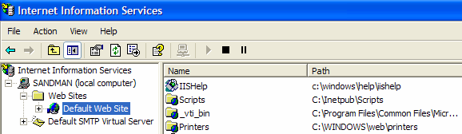

Now, right-click on the “Default Web Site” and choose “Properties”, then click the “Directory Security” tab:

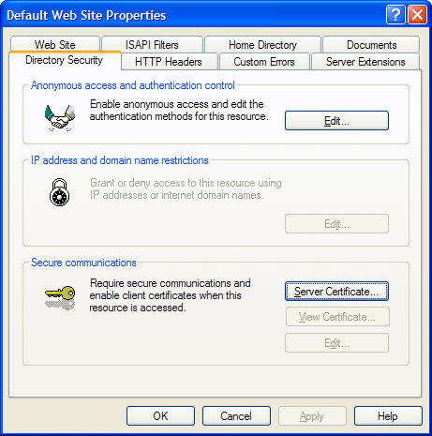

Now, click the button marked “Server Certificate”, click <Next> and choose the option marked “Create a new certificate”, and click <Next>. You can then choose to either prepare the certificate request and sent it later, or to send the certificate request immediately to an online CA. If you are using a third-party CA and are connected to the Internet choose the second option, otherwise choose the first option.

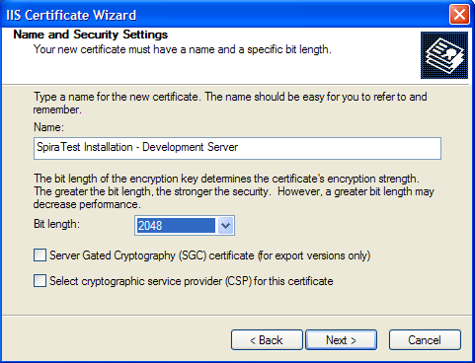

Enter the name for the certificate, typically this will contain the name of the organization, purpose of the certificate and any other pertinent information that will help you distinguish it.

You should choose a bit-length of at least 2048 bits, and leave the other options unchecked unless you are using the server outside of the United States, in which case you will need to choose the “Server Gated Cryptography (SGA)” option. Click the <Next> button when you are finished.

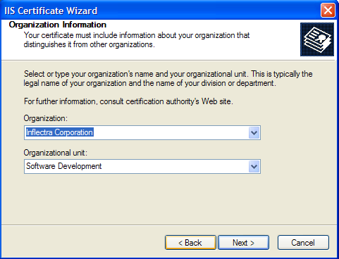

Now enter the organization and organizational unit name that best describes who is requesting the certificate. Click <Next> when you are finished.

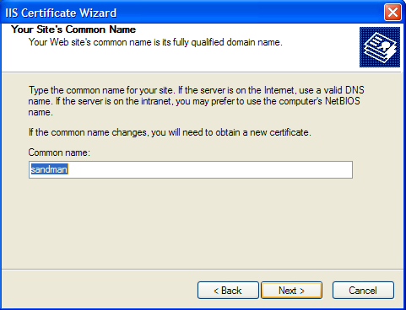

Next enter the “common name” for the web site that will be using the certificate. For a website that will be accessed across the Internet, this should the fully qualified domain name (e.g. [www.mysite.com](http://www.mysite.com/)), whereas for a website that is limited to a local intranet, the computer name will suffice (e.g. myhost). Click <Next> when you are finished.

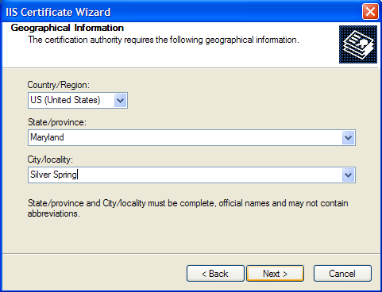

Next enter the country / region, state / province and city / locality that best describe where the web-server will operate or where the organizational entity resides. Once you are finished, click <Next>.

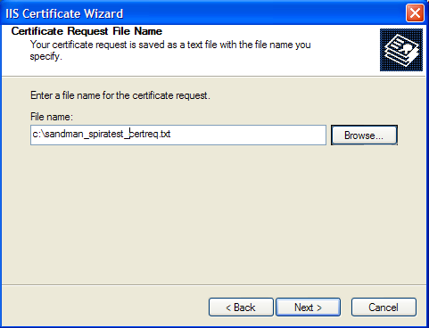

Next, enter the filename that you want to use for the *certificate request file*. This is the file that you will send to the Certificate Authority (CA) to request an SSL certificate. This filename should be memorable and describe what the certificate is for. The file extension should be .txt. Click <Next> once you have finished entering the filename.

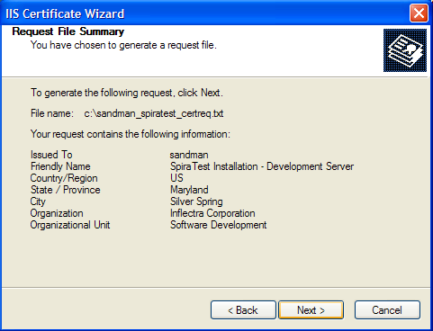

Finally, you will get a confirmation screen that verifies the information you have entered. If you want to make changes, click the <Back> button, otherwise click <Next> to actually generate the certificate. Once finished, you will now have the certificate request file that you can send to the Certificate Authority (CA) to process your request.

Once the CA has processed your request, they will send back the actual SSL certificate that you can install onto your web-sever. The next steps will describe how to install the certificate once you receive it back from the CA.

Once you have received the SSL certificate back from the CA, save the file onto your hard-disk with the file-extension .cer. Now open up the IIS management console (as described above), right-click on the “Default Web Site” icon and choose “Properties”. Now select the “Directory Security” tab, and click the button marked <Server Certificate> under the heading “Secure Communications”. When the dialog box appears, choose the second option – to process an existing request. This will bring up the following dialog box:

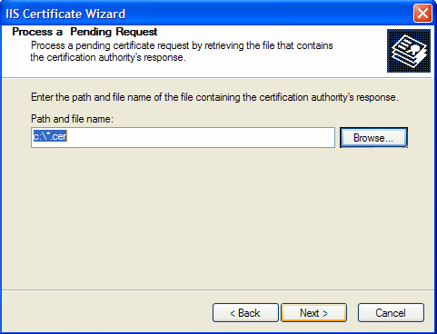

Now, browse to the place on your hard disk where you saved the SSL certificate (with extension .cer) and select the file you saved. Click <Next> to load the certificate. Once the certificate has been loaded, all that remains is to tell IIS to require a secure HTTPS connection, so that users don’t attempt to access the website over the unencrypted HTTP protocol.

From the IIS properties dialog box, click the button marked <Edit> under the “Secure Communications” heading:

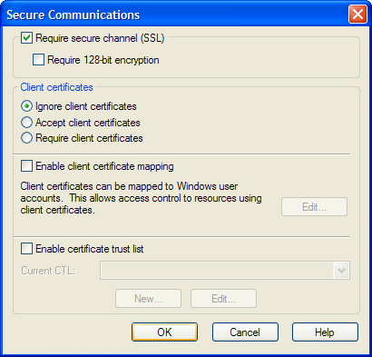

Check the box marked “Require secure channel (SSL)”, and click the <OK> button. You have now successfully configured IIS for secure HTTPS data transmission.

## 4.3. Appendix C – Sending Email through IIS

This section outlines the steps that you need to take to configure your IIS web server to send email notifications from KronoDesk®. Since email configurations can vary greatly between environments, please check with your local IT personnel for the correct settings that should be used. This section assumes that you have an SMTP mail-server available on your network that is capable of relaying the email from the IIS server.

First open up the Internet Information Services (IIS) Manager on your server and expand the Default SMTP Virtual Server node:

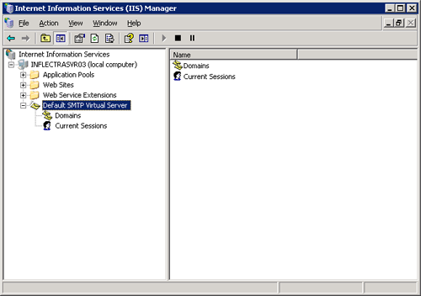

Right-click on the “Default SMTP Virtual Server” node and click on “Properties”. Then select the “Delivery” tab on the dialog box that pops-up:

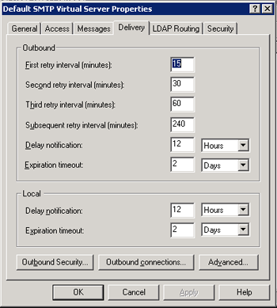

Now, click on the <Advanced> button to bring-up the advanced delivery configuration screen:

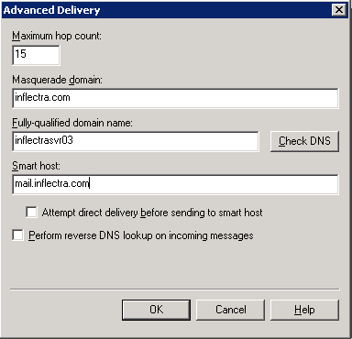

In this dialog box, you should enter the following information:

* **Masquerade domain:**  
  This is the domain name that you want emails from KronoDesk® to look like their being sent from. This is typically the domain name of your organization (e.g. mycompany.com)
* **Fully-qualified domain name:**  
  This is the fully qualified domain name of the IIS server that KronoDesk® is installed on (e.g. iisserver.mycompany.com).
* **Smart host:**  
  This is the fully qualified domain name of the SMTP mail-server that will actually be used in delivering the emails. (e.g. mail.mycompany.com). You will need to get the name of this from your IT personnel.

Once you have updated the settings, click the various <OK> buttons and you should now see emails being delivered from KronoDesk®. Note: the email address that is used as the ‘from address’ for all emails generated by KronoDesk® is the email address stored in the Administrator user’s profile. You should edit that user’s account and make sure their email address is a valid email address in your environment.

## 4.4. Appendix D – Upgrading

This section covers any important notes regarding differences between versions, and anything the Administrator or application owner may need to address upon upgrading. These are note release notes, but important changes in the application that may cause undesired application behavior when upgrading.

### 4.4.1. Version 1.x to 2.0:

The upgrade between these two versions is very major. Except for existing data (tickets, users, forum messages, etc.) the program manager should treat this as a completely new application, and verify all settings, configure the theme, and verify user security.

### 4.4.2. Version 2.0 to 2.1:

Major differences in this release of the application are centered on Organizations and user membership to organizations. There are a few page changes that should be addressed:

1. The Customer Home page (http://host/KronoDesk/External.aspx) has had its text shifted around. When logged into the application as an Administrator, you will be able to edit the text on this page by using the ‘Save’ bookmarks over each editable area.
2. The Email Verification (http://host/KronoDesk/Account/VerificationRequired.aspx) and Approval Required (http://host/KronoDesk/Account/ApprovalRequired.aspx) pages are now editable. The default text should work just fine, but you may wish to change it.

# Legal Notices

This publication is provided as is without warranty of any kind, either express or implied, including, but not limited to, the implied warranties of merchantability, fitness for a particular purpose, or non-infringement.

This publication could include technical inaccuracies or typographical errors. Changes are periodically added to the information contained herein; these changes will be incorporated in new editions of the publication. Inflectra® Corporation may make improvements and/or changes in the product(s) and/or program(s) and/or service(s) described in this publication at any time.

The sections in this guide that discuss internet web security are provided as suggestions and guidelines. Internet security is constantly evolving field, and our suggestions are no substitute for an up-to-date understanding of the vulnerabilities inherent in deploying internet or web applications, and Inflectra® cannot be held liable for any losses due to breaches of security, compromise of data or other cyber-attacks that may result from following our recommendations.

The section of the manual that describes modifying the Windows System Registry (“Registry”) should only be attempted by experienced Windows administrators who are familiar with its organization and contents. Inflectra® cannot be held liable for any losses due to damage to the system registry made by inexperienced personnel.

KronoDesk® and Inflectra® are either trademarks or registered trademarks of Inflectra Corporation in the United States of America and other countries. Microsoft®, Windows®, Explorer® and Microsoft Project® are registered trademarks of Microsoft Corporation. All other trademarks and product names are property of their respective holders.

Please send comments and questions to:

Technical Publications

Inflectra Corporation

8121 Georgia Ave

Suite 504

Silver Spring, MD 20910

U.S.A.

[*support@inflectra.com*](mailto:support@inflectra.com)